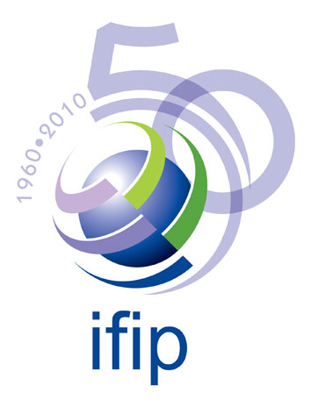 | International Federation for Information Processing  IFIP AGORA Initiative on Lifelong Learning  2007 Seminare  Questionnaire

From Bernard CORNU

Q1 : Can you describe your 3 main urgent priorities/"problems"/future tasks for your organisation?

- Put the technology and the pedagogy in harmony, in coherence, ensure that they develop simultaneously, enriching each other.
- Modernize not only the training, the courses, the teaching, but the processes and the systems for producing training and services; implement a real “knowledge management system”; enrich the tools for distance learning (platforms, collaborative tools, distance services, mobile and ubiquitous tools for learning…).
- Really use the results of research about distance learning, e-learning, etc. and experiment and implement them.

Q2 : What are the last two innovations/improvements/ new services you have introduced in your organisation during the last 5 years?

- An environment for distance learning (platform) including new kinds of services (such as oral activities, distance practical work for experimental sciences, evaluation…).
- Authoring tools and production tools for designing distance courses.
- Scenarization and multimediatization of pedagogical scenarios for distance education.

Q3 : How do you view the importance of lifelong learning for your organisation?

My organization (CNED – the French National Centre for Distance Education) has to implement e-Learning as the main field of development for distance education. At the school level, it is not so difficult. But we must develop e-Learning for adult education (in-service training, professional improvement, requalification, training for personal purpose or for the purpose of the employer, etc.). Lifelong Learning is more and more central in Society, CNED should be one of the main French LLL providers for companies, institutions, individuals… It needs to invent what LLL is, how it can use and be enriched by ICT, which products and services it needs, how we can prepare everyone (school pupils, students, adults) to be Lifelong Learners.

Q4 : Based on your experience, can you rank some problem areas by giving a score (1=not a priority to 5=burning topic)?

 | Problem area | Score: 1 - 5 | Remark
1. | Technology evolution | 3
2. | Social aspects/impacts | 5
3. | Digital Divide - Inequities | 5
4. | Sustainable Development | 3
5. | Access for all | 5
6. | Trust and confidence | 3
7. | Privacy and Data protection | 3
8. | Misuse - Ethics - Deontology | 5

… and the Pedagogy evolution ???? (ranked 5!).

Q5 : What are your key issues in the domain "e-Business" ?

Visibility, e-services for clients, quality control.

Q6 : What are your key issues in the domain "Security"?

Respect the privacy of users

Q7 : What are your key issues in the domain "Democratic Citizenship & Media"?

Provide equal access to e-Learning for all.
Increase democracy and citizenship through ICT tools.

Q8 : What are your key issues on the domain "e-Government"?

e-democracy; enhance the participation of citizen in the public and social life.

Q 9 : What are your key issues on the domain "e-Education"?

Make Education For All a reality with the aid of ICT.
Make sure that technology does not hide pedagogy and human aims.
Develop the collective intelligence, collaborative working abilities.
Have a deep and strong reflection about the evolution of school in the Knowledge Society, what schools will be in the future.
Have a deep and strong reflection about the evolution of the role of Teachers in the Knowledge Society, and how we can prepare and train them for their future role.

Q 10 : What are your key issues on the domain "Culture"?

Develop access for all to all cultures (globalization of cultures) AND preserve and reinforce local cultures. Make local cultures accessible globally.

Q 11 : What are your key issues on the domain "e-Health"?

Improve equity in access to health and medicine (with the help of ICT which can help distance medical acts).

Q 12 : What are the 3 main bottlenecks in the implementation of Lifelong Learning in your organisation?

- Adapt our pedagogy to Lifelong Learning and make it evolve in an interactive way together with technology.
- Move from a “teaching” perspective towards a “training” ands “learning” one.
- Adapt knowledge itself and access to knowledge to the Lifelong Learning stakes.

Q 13 : What are your concerns relating to Public-Private-Partnership/Joint Venture/Joint Projects?

Public educational institutions should increase their co-operation with private partners in order to take benefit from all the new developments and in order to be fully present and active in the Knowledge Economy. It is the only way for ensuring that knowledge is a Public Good and Education a Public Service, otherwise schools will disappear, killed by the development of the private educational offers

Q 14 : Do you have other inputs for the 2007 AGORA seminar on Lifelong Learning?

Inputs | Web address | Remarks
Projects, results
Questions, needs
Other remarks

