

IFIP TC3 Action Plan 2005 - 2009

Version 1
Updated January 2006

With contributions from:

WG 3.1 Informatics and ICT in Secondary Education
WG 3.2 Informatics and ICT in Higher Education
WG 3.3 Research on Education Applications of IT
WG 3.4 IT-Professional and Vocational Education in IT
WG 3.5 Informatics in Elementary Education
WG 3.6 Distance Learning
WG 3.7 Information Technology in Educational Management
SIG 3.8 Special Interest Group on Lifelong Learning

0. Content

IFIP TC3 Action Plan 2005 - 2009 1
Version 1 1
0. Content 2
IFIP TC3 website 3
1 Context of TC3 activities 4
1.1 Community of Practice of professionals 4
How will we work? 4
1.2 Key themes 4
What will be the key issues we work on? 4
1.3 Middle term strategic action plan 4
What are our strategic activities? 4
Action Plan framework 4
Activities and results 5
2. TC3 activity plan 6
2.0 TC3 meetings 6
2.1 National reports to TC3 6
2.2 Relations with other TCs 6
2.3 IFIP World Computer Congress 6
2.4 UNESCO 6
National Commissions 6
IITE 6
UNESCO Bangkok Office 6
UNESCO Headquarters 6
World Summit on the Information Society 6
1.5 Relations with the European Community 7
Relationships 7
European networks 7
European Projects 7
Reciprocal visibility 7
New European Countries 7
1.6 Relations with Asia 7
1.7 World Conference Computers and Education (WCCE) 7
1.8 IFIP TC3 Journal 7
Education and Information Technologies 7
Description 8
1.9 IFIP TC3 Conference Management System ICMS 8
3. Working Group Activity Plans 11
3.1 Secondary Education 11
Imaging the future for ICT and education 11
3.2 Higher Education 12
3.3 Research on Educational Applications of ICT 12
3.4 IT-Professional and Vocational Education in ICT 13
3.5 Elementary Education 13
3.6 Distance Learning 13
3.7 Information Technology in Educational Management 14
3.8 Special Interest Group on Lifelong Learning 14
3.9 Overview of themes and activities 15

IFIP TC3 website
This document is part of the IFIP TC3 resource base that is to be found on the IFIP TC3 website:
www.ifip.or.at; select: TC-3 Education; select: TC 3; select: URL: http://wwwedu.ge.ch/cptic/prospective/projets/ifip/

1 Context of TC3 activities
Our society, and with it education, is continuing to change and the rate of change is increasing, with a prominent role for informatics and ICT. Contribution to innovation; new ethical rules.
To contribute both to the ongoing development of informatics teaching and the educational uses of communication and information technologies (ICTs) IFIP TC3 has to take account of these changes, both in its way of working and in the key themes it addresses.

1.1 Community of Practice of professionals

How will we work?
To provide an international forum for educators to discuss research and practice through
- A network of Communities of Practice working together
- Adding community value by building on and enhancing community resources (implying re-use of added value resources)
- Using a transparent and open system of quality assurance in all work (implying quality of added value)
- Being aware of the relationships with other professional areas

1.2 Key themes

What will be the key issues we work on?
- Models of how to make Educational Communities of Practice a success
- Models of how to design and implement learning environments for lifelong learning in our changing society, taking into account:
  - formal and informal environments for teaching and learning
  - administration and management of the educational enterprise
  - local, national and regional policy-making and collaboration.

1.3 Middle term strategic action plan

What are our strategic activities?
- IFIP TC3 Strategy Paper in journal
- Presenting comprehensive synthesis of research on:
  - Educational Communities of Practice (CoP Task Group)
  - Learning environments (CoP Task Group), including:
  - Learning environments for informatics education (WG 3.2/WG3.4/…)
- Development of one new partnership, with new actors, in another modality and with non-book results that are followed-up
- Update of TC3 Strategy Document on new locations, targeted participants, actors, modalities, outputs and follow-up.

Action Plan framework
What is the idea?
By what CoP method
How specifically
What specific CoP result
Who
When
Where

Activities and results
Activities | Results
IFIP meetings | Strategy and Planning
Group consultancy | Investigative, descriptive report
Seminar, Workshop | Professional updating
Working meeting/Focus Group/Professional Group | Recommendations, Report, Publication
Working Conference | Interest, Sharing, Review, Recommendations, Publication
Open Conference | Interest, Sharing, Publication
eConference/eMeeting | Recommendations, Report, Publication
Journal | Review, Publication

2. TC3 activity plan

2.0 TC3 meetings

TC3 Officers Meeting: June 23, Ǻlesund, Norway
TC3 Meeting: June 24 – 25, Ǻlesund, Norway

Responsible for follow-up: TC3 Chair: Jan Wibe

2.1 National reports to TC3

Responsible for follow-up: Vice-chair Anne Mc Dougall

2.2 Relations with other TCs

Responsible for follow-up: TC3 Chair: Jan Wibe

2.3 IFIP World Computer Congress

Responsible for follow-up: Sindre Rosvik

Activity | Title | Dates | Venue | IPC Chair | Contact
TC3 stream in IFIP World Computer Congress | Education for the 21th century | August 20-25 2006 | Santiago  Chili | Sindre Rosvik | www.ifip.or.at

2.4 UNESCO

Responsible for follow-up: TC3 secretary Bernard Cornu
In cooperation with Special Consultant: Raymond Morel

National Commissions

IITE

UNESCO Bangkok Office

UNESCO Headquarters

World Summit on the Information Society

2.5 Relations with the European Community

Responsible for follow-up: TC3 secretary Bernard Cornu
In cooperation with Special Consultant: Raymond Morel
Relationships

European networks

European Projects

Reciprocal visibility

New European Countries

2.6 Relations with Asia

Follow-up to be determined

2.7 World Conference Computers and Education (WCCE)

Responsible for follow-up: TC3 Chair: Jan Wibe
With John Hughes (IPCC) and Raul Waslawick (OCC)

Activity | Title | Dates | Venue | IPC Chair  OC Chair | Contact
TC3 World Conference Computers in Education | 9th WCCE | July 27 – 31 2009 | Florianopolis  Brazil | John Hughes (IPCC)  Raul Waslawick (OCC) | www.wcce2009.org

2.8 IFIP TC3 Journal

Education and Information Technologies

Responsible for follow-up: EAIT Editor Deryn Watson

The Official Journal of the IFIP Technical Committee on Education
Editor-in-Chief: D. Watson
ISSN: 1360-2357 (print version)
ISSN: 1573-7608 (electronic version)
Journal no. 10639
Springer US

Online version available
http://www.springeronline.com, select Education, select Journals

Description
Aims of the Editors:

It is our determination to develop this journal into a key international voice in the growing and significant field of education and information technologies.

This journal is a platform for the range of debates and issues that are current in our field. It is a broad field; we aim to provide perspectives at all levels, from the micro of specific applications or instances of use in classrooms to macro concerns of national policies and major projects; from classes of five year olds to adults in tertiary institutions; from teachers and administrators, to researchers and designers; from institutions to open, distance and lifelong learning. The strength of this breadth lies in the opportunity to raise and debate fundamental issues at all levels, to discuss specific instances and cases, draw inference and probe theory. This journal is embedded in the research and practice of professionals. It will not proselytise on behalf of the technologies but rather provoke debate on all the complex relationships between information and communication technologies and education.

As editors we are determined to maintain and expand the international standing of Education and Information Technologies by careful selection on merit of the papers submitted to us. Our goal is that we should provide an ongoing forum for debate. We shall occasionally produce special editions to enable us to cover particular issues at depth.We invite you, our readers, to send us papers on your work for consideration for inclusion, but also to comment and reflect upon the argument and opinions that we shall be publishing.

Abstracted/Indexed in:
Communication Abstracts, Computer Literature Index, Higher Education Abstracts, Inspec, MathDi, SCOPUS

2.9 IFIP TC3 Conference Management System ICMS

Responsible: Anton Knierzinger, IFIP TC3 Special consultant for Conference Management:
a.knierzinger@ist.eduhi.at
Tel: ++43 (0)732 788078
Fax: ++43 (0)732 788078 88

The whole systems works only online.
everyone has the same status of information
cooperation on distance is supported
access to all functions via net
The system is role based (visitors, presenters, reviewers, organizers, admins)
Functions can be customized for every conference.

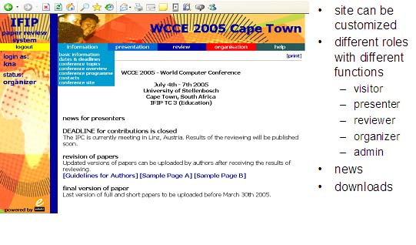

Functions:
- information on paper handling for authors
- upload of abstracts and papers
- administration of and communication with reviewers
- online abstract and paper reviewing
- communication with presenters
- support for IPC meeting (lists, statistics,...)
- compilation of conference programme

Functions for presenters:

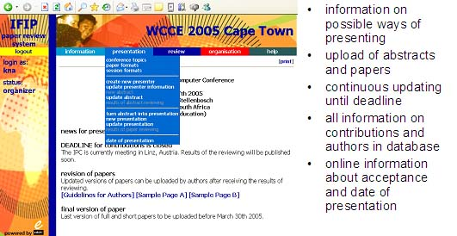

Functions for reviewers:

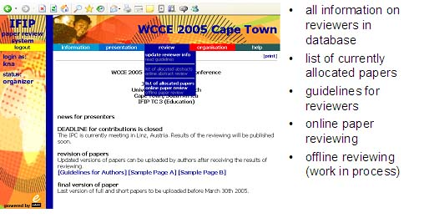

On-line reviewing:

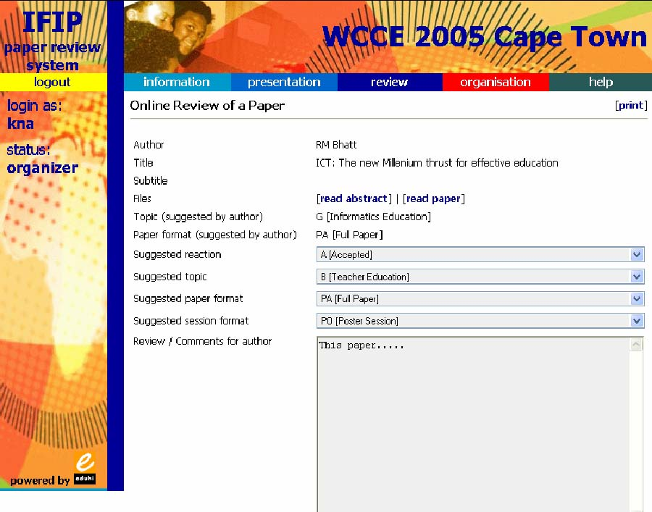

Functions for organisers:

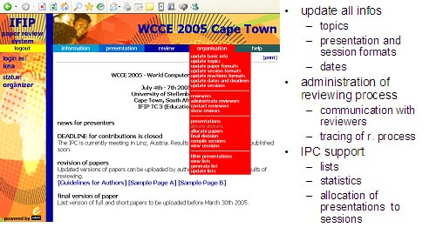

3. Working Group Activity Plans

Responsible for follow-up: Vice-chair for working groups Tom van Weert

3.1 Secondary Education
Chair: Deryn Watson

Activity | Title | Dates | Venue | Chair | Contact
Open Conference with WG 3.3, 3.5 | Imaging the future for ICT and education | June 26 – 30 2006 | Alesund, Norway | Sindre Rosvik (IPC)  Deryn Watson (IPC) | http://ifip35.inf.elte.hu/alsund
Open conference | Teaching informatics in schools | 2007 | Boston  USA | Pieter Hogenbirk (IPC)
TC3 World Conference Computers in Education | 9th WCCE | July 27 – 31 2009 | Florianopolis  Brazil | John Hughes (IPC)  Raul Waslawick (OC) | www.wcce2009.org

Imaging the future for ICT and education
26th – 30th June 2005 in Alesund, Norway

This conference will be an opportunity to combine our experience and imagination for thinking “beyond the box” by:
- looking into what has not worked and what may work
- exploring new and different structures for teaching, learning and professionalism
- re-thinking assessment and evaluation
- linking research and practitioner networks and knowledge
- new conversations between emerging formal, informal and lifelong learning communities
- developing content and methodologies for the needs – local, national and global – of the 21st century.

Thus there is scope for considering new relationships between home, community, school and the wider world. Topics within these themes could include:
- which subjects are/are not influenced by the new media?
- how do the young approach gaming?
- evidence of real change
- explaining residual resistences to using ICT in education
- what do we learn from national research /evaluation studies of ICT?
- can we establish ‘success’ factors?
- identifying robust research questions?
- posing ethical questions raised in the information society

2006 is the anniversary of the establishment of the first working group of IFIP Education Committee; forty years on is an opportunity to reflect on the past and present to spur on notions for the future.

A Call for Participation
It is our intention to provide a forum for school and community practitioners, lecturers and researchers, advisers and policy makers. But also for doctoral students, newly qualified teachers and young people to contribute their perspectives, as the future is theirs. We also plan to host interactive eb=vents and webcasts. We invite all to attend and contribute.

Conference activities
The conference will feature papers, panels, workshops, focus groups and adversarial debates. Proposals for each of these session types are invited. All proposals will be refereed; acceptance is subject to the outcome of the review process.

Further details of these activities and how to submit can be found on the conference web-site
http://ifip35.inf.elte.hu/alsund

Publication
A book of abstracts, including paper abstracts, details of panels, workshops, focus groups and adversarial debates, will be published and made available to conference attendees.
All full and short papers, together with the text from the book of abstracts, will be published on a conference CD-ROM. All conference attendees will receive a copy.
Selected papers will be published in a special edition of the international refereed journal “Education and Information Technologies”.

Important dates
- Paper and proposed contribution deadline: December 16, 2005
- Notification of acceptance: March 7, 2006
- Conference dates June 26-30, 2006

Come to Alesund for conversations between communities of practice – for a collective exploration of the challenge of change.

Programme chairs:
Deryn Watson(UK) and Sindre Rosvig (NO)
Programme Committee:
David Benzie (UK)
Paul Deakin (AUS)
Helene Godinet (F)
Robert Munro (UK)
Marta Turcsanyi-Szabo (HU)
Leena Vainio (FI)
Wolfgang Weber (DE

3.2 Higher Education
Chair: John Hughes

Activity | Title | Dates | Venue | Chair | Contact
IFIP WCC2006, in cooperation with WG 3.4, 3.5 and SIG 3.8 | TC3-stream | August 20-25, 2006 | Santiago,  Chili | Sindre Rosvik (Stream) | www.wcc-2006.org
TC3 World Conference Computers in Education | 9th WCCE | July 27 – 31 2009 | Florianopolis  Brazil | John Hughes (IPC)  Raul Waslawick (OC) | www.wcce2009.org

IFIP Congress 2006:
TC3 stream: Education for the 21st Century - Impact of ICT and Digital Resources
- CTEM II: Informatics Curricula, TEaching Methods and best practice
- Teaching and Learning with ICT: Theory, Policy and Practice - From the world of research to classrooms and learning environments
For further information http://www.wcc-2006.org/

3.3 Research on Educational Applications of ICT
Chair: Paul Nicholson

Activity | Title | Dates | Venue | Chair | Contact
Stream on LLL and Knowledge Development in Open Conference with WG 3.3, 3.5 | Imaging the future for ICT and education | June 26 – 30 2006 | Alesund, Norway | Sindre Rosvik (IPC)  Deryn Watson (IPC) | http://ifip35.inf.elte.hu/alsund
Working conference | Research issues accross cultures | June/July 2007 | Budapest, Hungary | Andrea Karpati (OCC)
Open or working conference |  | July 2008 | Bangkok
TC3 World Conference Computers in Education | 9th WCCE | July 27 – 31 2009 | Florianopolis  Brazil | John Hughes (IPC)  Raul Waslawick (OC) | www.wcce2009.org

3.4 IT-Professional and Vocational Education in ICT
Chair: Barry Thompson

Activity | Title | Dates | Venue | Chair | Contact
IFIP WCC2006, in cooperation with WG 3.2, 3.5 and SIG 3.8 | TC3-stream | August 20-25, 2006 | Santiago,  Chile | Sindre Rosvik (Stream) | www.wcc-2006.org
TC3 World Conference Computers in Education | 9th WCCE | July 27 – 31 2009 | Florianopolis  Brazil | John Hughes (IPC)  Raul Waslawick (OC) | www.wcce2009.org

IFIP Congress 2006:
TC3 stream: Education for the 21st Century - Impact of ICT and Digital Resources
- CTEM II: Informatics Curricula, TEaching Methods and best practice
- Teaching and Learning with ICT: Theory, Policy and Practice - From the world of research to classrooms and learning environments
For further information http://www.wcc-2006.org/

3.5 Elementary Education
Chair: Sindre Rosvik

Activity | Title |  |  | Dates |  | Venue |  | Chair |  | Contact
Open Conference with WG 3.1, 3.3 |  | Imaging the future for ICT and education | June 26 – 30 2006 |  | Alesund, Norway |  | Sindre Rosvik (IPC)  Deryn Watson (IPC) |  | http://ifip35.inf.elte.hu/alsund
IFIP WCC2006, in cooperation with WG 3.2, 3.4 and SIG 3.8 | TC3-stream |  |  | August 20-25 |  | Santiago, Chile |  | Sindre Rosvik (Stream) |  | www.wcc-2006.org
TC3 World Conference Computers in Education | 9th WCCE |  |  | July 27 – 31 2009 |  | Florianopolis  Brazil |  | John Hughes (IPC)  Raul Waslawick (OC) |  | www.wcce2009.org

Please see 31. Secondary Education for a description of the Open conference Imaging the future for ICT and education

IFIP Congress 2006:
TC3 stream: Education for the 21st Century - Impact of ICT and Digital Resources
- CTEM II: Informatics Curricula, TEaching Methods and best practice
- Teaching and Learning with ICT: Theory, Policy and Practice - From the world of research to classrooms and learning environments
For further information http://www.wcc-2006.org/

3.6 Distance Learning
Chair: Elisabeth Stacey

Activity | Title | Dates | Venue | Chair | Contact
TC3 World Conference Computers in Education | 9th WCCE | July 27 – 31 2009 | Florianopolis  Brazil | John Hughes (IPC)  Raul Waslawick (OC) | www.wcce2009.org
TET 2007 |  |  | Prague  Tsjech republic

3.7 Information Technology in Educational Management
Chair: Adrie Visscher

Activity | Title | Dates | Venue | Chair | Contact
Working Conference Working Group 3.7  (ITEM) | “Knowledge management for educational innovation” | July 23-26, 2006 | Hamamatsu (Japan) | Toshio Okamoto  Adrie Visscher | okamoto@ai.is.uec.ac.jp  a.j.visscher@gw.utwente.nl
Working Group 3.7 (ITEM) Conference | ITEM 2008 | July 2008 | Melbourne | Arthur Tatnall  Adrie Visscher | Arthur.Tatnall@vu.edu.au  a.j.visscher@gw.utwente.nl
TC3 World Conference Computers in Education | 9th WCCE | July 27 – 31 2009 | Florianopolis  Brazil | John Hughes (IPC)  Raul Waslawick (OC) | www.wcce2009.org

3.8 Special Interest Group on Lifelong Learning
Chair: Brian Samways

Activity | Title | Dates | Venue | Chair | Contact
Stream on LLL and Knowledge Development in Open Conference with WG 3.3 | Imaging the future for ICT and education | June 26 – 30 2006 | Alesund, Norway | Sindre Rosvik (IPC)  Deryn Watson (IPC) | http://ifip35.inf.elte.hu/alsund
IFIP WCC 2006 in cooperation with WG 3.2, 3.4 and 3.5 | Lifelong Learning stream | 2006 | Santiago  Chili | Sindre Rosvik (Stream) | www.wcc-2006.org
TC3 World Conference Computers in Education | 9th WCCE | July 27 – 31 2009 | Florianopolis  Brazil | John Hughes (IPCC)  Raul Waslawick (OCC) | www.wcce2009.org

3.9 Overview of themes and activities
Activities | WCCE | Open  Conf. | Work.  Conf. | Work-  shop | Prof.  Group | eConf./  eMeet | Journal | Follow-Up  Document  Focus group | Ad  hoc  seminar | Event in  conjunction  with  others
Themes
Lifelong Learning
Open and Distance
Learning
Cost-
Effectiveness
Disiplines
(art, science, ..)
Learning
Styles
Learning environment
Learning visions
Professionalism
Change
management
Global and local
Social and ethical
Knowl.based v.
Competence b. learning
Curriculum issues
Real life learning
Educational policies
Development of TC3 as a thematic network
Knowledge management for educational innovation |  |  | 3.7

TC3 = Technical Committee 3
3.1 = Working Group 3.1
SIG = Special Interest Group Lifelong Learning

Table 1 Themes and modalities of TC3 activities

