Ateliers and Studios for
Lifelong Learning in a Knowledge Society

Report

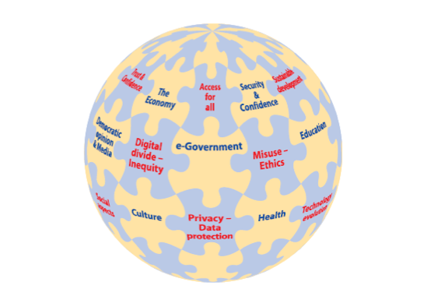

Tom van Weert


4th IFIP Agora Seminar, May 4-6, 2008
Krakow, Poland

Contents
0. Executive summary 3
1. Knowledge society, dealing with the e-Change Puzzle 5
1.1 ‘Digital Life’ 5
1.2 ‘e-Change’: dealing with a moving target 5
1.3 Knowledge Society 6
1.4 References 7
1.5 IFIP Agora literature 7
2. Professionals in the knowledge based economy 8
2.1 The knowledge worker 8
3. Key competencies of knowledge workers 10
3.1 Key competencies 10
3.2 Lifelong Learning: reflectiveness 11
3.3 References 12
3.4 IFIP Agora literature 13
4. How to educate knowledge workers 14
4.1 Digital Literacy and e-inclusion in schools 14
4.2 Evolving Discourses and Practices of Lifelong Learning 16
4.3 Educating knowledge workers 18
5. Organisations in the knowledge society 23
5.1 Success factors 23
5.2 Maturity levels 24
5.3 Lifelong learning of organisations 25
5.4 How to promote lifelong learning in educational organisations 27
6. Co-operation projects: Case studies 29
6.1 New AGORA atelier on basic assumptions for education process integrated with ICT and LLL 29
6.2 Partnership in Malopolska for The Lifelong Learning 31
6.3 The role of career guidance in Lifelong Learning 32
6.4 eSchool: New Technology, New Learning 34
6.5 E-learning in Life-Long Learning. Academic Approach 36
6.7 Examplifying alternative approaches to important aspects of AGORA 40
6.8 National computer societies – the role of TC’s 42
6.9 The “Cyber-Teacher” Studio 44
6.10 Preparing Future Professionals for Lifelong Learning in Higher Education and in Business Academies 46
7. Implementation strategy for new studios and ateliers 48
8. IFIP Agora Initiative on Lifelong Learning 50
8.1 Agora Initiative and Lifelong Learning in the World Conference Computers in Education 2009 50
8.2 Agora: An IFIP Initiative 52
8.3 History of the IFIP AGORA Initiative 55
9. Krakow seminar organisation 57
9.1 List of participants 57
9.2 Draft programme 58

0. Executive summary
Lifelong Learning is a central issue in the knowledge society. The IFIP Agora Initiative aims to develop new forms of collaboration between partners and stakeholders, based on the principle of Lifelong Learning. It also aims to develop Lifelong Learning solutions for students and professionals.
The AGORA Initiative, an element of the process of revitalisation of the IFIP strategy, aims at implementing a dynamic methodology for initiating cooperation projects on Lifelong Learning with many different stakeholders. It is providing a methodical concept of action where contextual local efforts are connected to each other and contribute to generic common knowledge about Lifelong Learning in a synergetic manner.
The AGORA Initiative for Lifelong Learning aims, on an annual basis, at promoting synergy between different kinds of actors, gathering updated priorities of each partner, adjusting the problematic all along the evolution of main international programmes, facilitating the networking of partners, taking into account the emerging needs in Lifelong Learning in the Information Society, promoting new projects, acting as a catalyst for the IFIP community, following the New Strategy of IFIP.
Main Objectives
A. Dynamic and generic methodology for project initiation
How to initiate a network of cooperation projects with many different stakeholders?
B. Co-operation projects
Aimed at enhancing e-competence and knowledge work competence of professionals and students
C. Methodical approach to knowledge sharing
Allowing contextual, local project efforts to be connected, contributing in a synergetic manner to generic knowledge about Lifelong Learning
Actions
A. Planning meetings (Poitiers, Paris, Seoul, …)
- Bringing together stakeholders and project initiators
- Knowledge sharing, networking and developing synergy
- Outlining of co-operation projects
- Defining work process for planning and co-operation
B. Seminars (Poitiers, Seoul, Addis Ababa, Krakow, Kuala Lumpur…)
- Sharing of local, contextual knowledge
- Interactive development of conceptual frameworks
C. Co-operation projects (4 in initiation phase)
- Managing Lifelong Learning Studio
- Digital Divide Studio
- Cyber-Teacher Studio
- Croatian Studio

IFIP Agora Krakow Seminar
The seminar was organised by Barbara Kędzierska of the European Centre for Lifelong Learning and Multimedia Education, the Pedagogical University of Krakow.
The Krakow seminar was aimed at sharing of local, contextual knowledge and interactive development of conceptual frameworks. The seminar addressed the following issues:
- Knowledge society, dealing with e-change
- Professionals as knowledge workers in the knowledge society
- Key competencies of knowledge workers
- How to educate knowledge workers and citizens
- Organisations in the knowledge society
- Co-operation projects
- Implementation of new studios and ateliers

1. Knowledge society, dealing with the e-Change Puzzle
Seminar contribution: Tom van Weert
Lifelong Learning of professionals (Addis Abeba 2.0)

1.1 ‘Digital Life’
Our informatics society is turning into an information and knowledge society where ICT brings changes to all aspects of work and also all aspects of life. According to the International Telecommunication Union (ITU) this ‘e-Change’ is moving us towards ‘Digital Life’ (ITU 2006). In Digital Life the technology has become ubiquitous. Information and Communication Technology (ICT) in Digital Life is a facilitator like electricity: not noticed until not available. The problems that have to be solved in Digital Life are part of a multi-facetted puzzle in which many different ICT-issues play a part, such as:
- Technology evolution
- Social impacts
- Digital Divide – Inequity
- Sustainable development
- Access for all
- Trust and Confidence
- Privacy and Data protection
- Misuse - Ethics
- …..

These issues affect many different areas of interest such as:
- e-Business
- Security
- Democratic citizenship and media
- e-Government
- e-Education
- Culture
- e-Health
- …….

What results is a complex Digital Life Puzzle:

1.2 ‘e-Change’: dealing with a moving target
e-Change is fast and the Digital Life Puzzle is like a moving target. For example, according to ITU (2006) broad band use has developed in an exponentional way. Broad band networks support ubiquitous digital networks that contain many computers for one person (ITU 2006). Ubiquitous digital networks offer among others:
- Mobile broadband,
- Portable internet
- Connected computing (radio-frequency identification, sensors & actuators, media convergence)
- Instant messaging.
Also, according to ITU (2006) users, especially the young, are embracing, but also demanding new ICT services at a high rate.
How can professionals and organisations deal with this fast e-Change? They use a working method that allows them to hit a moving target. A well-known form of this working method is the Deming-cycle: ‘Plan, Do, Check, Act’ (PDCA).
From Wikipedia, the free encyclopedia

PLAN: establish the objectives and processes necessary to deliver results in accordance with the specifications.
DO: implement the processes.
CHECK: monitor and evaluate the processes and results against objectives and specifications and report the outcome.
ACT: apply actions to the outcome for necessary improvement. This means reviewing all steps (Plan, Do, Check, Act) and modifying the process to improve it before its next implementation.
Velocity of change is a key competitive factor in today's world. PDCA allows for quantum breakthroughs (typical Western approach), as well as Kaizen (typical Eastern Lean approach with continuous improvement); thereby providing the best of both worlds. In this way, PDCA helps ensure the fastest rate of improvement; often a critical success factor.
PDCA should be repeatedly implemented, as quickly as possible, in upward spirals that converge on the ultimate goal, each cycle closer than the previous. This approach is based on the understanding that our knowledge and skills are always limited, but improving as we go. Often, key information is unknown, or unknowable. Rather than enter "analysis paralysis" to get it perfect the first time, it is better to be approximately right than exactly wrong. Over time and with better knowledge and skills, PDCA will help define the ideal goal, as well as help get us there.
For learning the ACT-element in the PDCA-cycle is of critical importance. It allows professionals and organisations to adjust. In this context the PDCA-cycle takes the form of a PDCR-cycle:

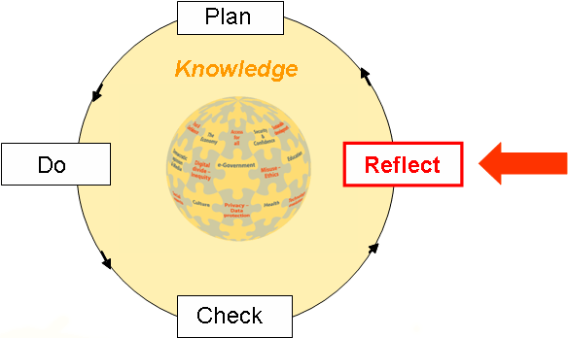

1.3 Knowledge Society
The fast ‘e-Change’ to ‘Digital Life’ impacts on every aspect of our society. “Technological change and innovation drive the development of the knowledge-based economy through their effects on production methods, consumption patterns and the structure of economies.” (OECD 2000).
“A knowledge-based economy relies primarily on the use of ideas rather than physical abilities and on the application of technology rather than the transformation of raw materials or the exploitation of cheap labor. Knowledge is being developed and applied in new ways. Product cycles are shorter and the need for innovation greater. Trade is increasing worldwide, increasing competitive demands on producers. … In the knowledge economy, change is so rapid that workers constantly need to acquire new skills. Firms need workers who are willing and able to update their skills throughout their lifetimes.” (World Bank 2002; p.ix).
The nature of the concept of knowledge is changing. The term ‘knowledge’ has changed in meaning from pure theoretical knowledge (old knowledge) to more application oriented, prescriptive knowledge (new knowledge). New knowledge is produced in what Gibbons (1996) has characterised as ‘Mode 2’: “Knowledge production carried out in the context of application” marked by its context- and use-dependence.” The ability that is needed to solve problems within non-routine tasks requires competence in finding, handling and creating relevant knowledge (Elkjaer 2000). Because of this knowledge development has been democratised and is becoming a normal part of knowledge work in the REFLECT-activity of the PDAR-cycle.

1.4 References
Elkjaer, B. (2000) Learning and getting to know: the case of knowledge workers. Human Resource Development International, 3, 343-360.
Gibbons, Michael, Camille Limoges, Helga Nowotny, Simon Schwartzman, Peter Scott & Martin Trow (1994) The new production of knowledge: the dynamics of science and research in contemporary societies. London, etc.: Sage.
International Telecommunication Union (2006) Digital Life. ITU Internet report 2006. Geneva: ITU. http://www.itu.int/osg/spu/publications/digitalife/
OECD (2000) A new economy? The changing role of innovation and information technology in growth. Paris: Organisation for Economic Co-operation and Development.
World Bank (2002) Lifelong Learning in the Global Knowledge Economy: Challenges for Countries. Washington D.C.

1.5 IFIP Agora literature
Tom van Weert & Raymond Morel (2007) Seoul 2.0 Model. A learning organisation for lifelong learners. IFIP Agora Initiative, Laxenburg. http://www.ifip-tc3.net/article.php3?id_article=146
Tom van Weert & Mike Kendall (2007) How to create a lifelong learning environment. IFIP Agora Initiative, Laxenburg. http://www.ifip-tc3.net/article.php3?id_article=146

2. Professionals in the knowledge based economy

2.1 The knowledge worker
Seminar contribution: Lampros Stergioulas
A FORESIGHT STUDY OF TECHNOLOGY-ENHANCED PROFESSIONAL LEARNING IN EUROPE - Challenges, Technologies, and Future Trends
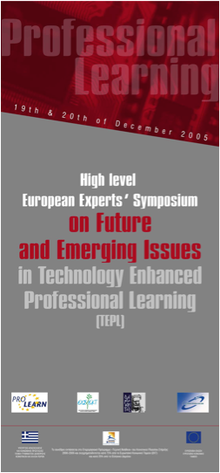
Symposium main conclusions
Greater understanding is needed of what the knowledge worker needs are and what the skills and competencies in the new knowledge society and knowledge work should be.
An important change relating to the organization of jobs and company structures is emerging, which tends towards the demise of hierarchy as well as of specific titles and job descriptions, with a strong tendency towards flexible types of jobs defined by the particular “project” assignments.
An increased imbalance of education was identified between higher ranked and lower ranked employees, as well as between small and large enterprises. In reality, “the future is already here but unequally distributed”.
The most-likely-to-succeed future type of training will be the “personalized learning”, which offers to the specific person the right skills, at the right time within the specific context (work, social, technical, cognitive etc).
We also observe an increasing convergence between formal and informal training.
The vision for the future Knowledge Workers focuses on three main axes:
- promotion of innovation, creativity, proficiency and flexibility in learning and work,
- maximum employability of the European labor force, and
- equal opportunities in education and career.
The management of human resources has to change and learning has to be integrated with the working and business processes.
Time-to-proficiency becomes increasingly important in order for the European companies to stay competitive.
The training programmes have to be aligned with the strategic goals of the enterprise.
A tendency of convergence between work and personal life is observed, where the lines between learning and work, work and leisure, and also formal, informal, non formal forms of learning, are becoming more and more blurred.
The need of greater flexibility in professional development is a stress-inducing factor for the employees, as it creates intense feelings of insecurity towards work.
Core vision of TEPL in 2015
“Support knowledge workers with technology-enhanced learning by promoting motivation, performance, collaboration, innovation and commitment to lifelong learning.”
A knowledge worker is someone who:
- doesn’t just consume knowledge but who is able to create it
- reflects critically on every level of activity in the organization and contributes back.

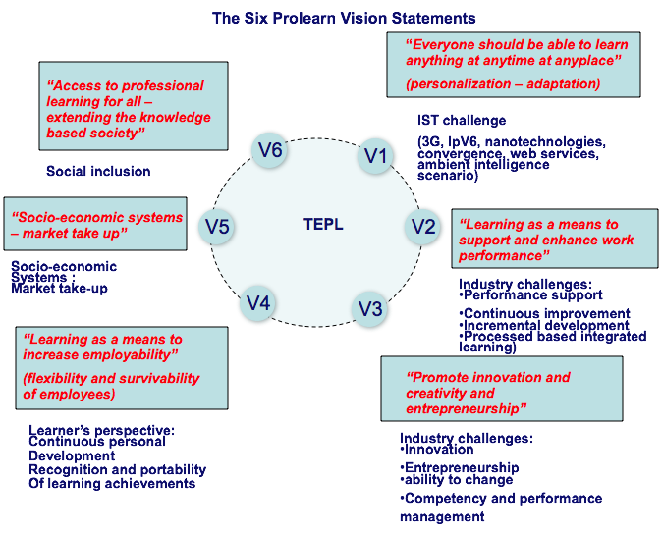

3. Key competencies of knowledge workers
Seminar contribution: Tom van Weert
Lifelong Learning of professionals (Addis Abeba 2.0)

3.1 Key competencies
A knowledge-based economy relies primarily on the use of ideas (knowledge) rather than physical abilities:
- Application of ideas
- Creation of ideas
- Sharing of ideas
And on the application of technology rather than the transformation of raw materials or the exploitation of cheap labour (World Bank 2002).
For a knowledge worker who works in the Deming PDCR-cycle this implies applying, creating and sharing knowledge connected with the PDCR-cycle activities.

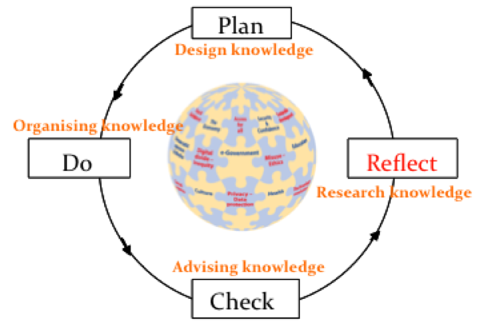

This implies that a knowledge worker needs to combine the competencies of a Designer, an Organiser, an Adviser and a Researcher.
According to the OECD DeSeCo-project (OECD 2003) the key competencies of the knowledge worker fall into 3 categories:
- Use tools interactively
- Interact with language and symbols
- Interact with knowledge and information
- Interact with technology
- Interact in heterogeneous groups
- Relate to others
- Cooperate
- Manage and resolve conflicts
- Act autonomously
- Act within big picture
- Form plans and conduct personal projects
- Assert rights, interests, limits and needs
These key competencies can be grouped in a different way under the headings of Designer, Organiser, Adviser and Researcher in the following way:

Researcher
1.A Interact with language & symbols
1.B Interact with knowledge & information
1.C Interact with technology
Designer
3.A Act within big picture
1.C Interact with technology
Adviser
2.A Relate to others
2.B Cooperate
2.C Manage and resolve conflicts
1.C Interact with technology
Organiser
3.B Form plans and conduct personal projects
3.C Assert rights, interests, limits and needs
1.C Interact with technology

3.2 Lifelong Learning: reflectiveness
According to the OECD DeSeCo-project (OECD 2003) reflectiveness is at the heart of key competencies:
“An underlying part of this <competency> framework is reflective thought and action. Thinking reflectively demands relatively complex mental processes and requires the subject of a thought process to become its object. For example, having applied themselves to mastering a particular mental technique, reflectiveness allows individuals to then think about this technique, assimilate it, relate it to other aspects of their experiences, and to change or adapt it. Individuals who are reflective also follow up such thought processes with practice or action. Thus, reflectiveness implies the use of metacognitive skills (thinking about thinking), creative abilities and taking a critical stance. It is not just about how individuals think, but also about how they construct experience more generally, including their thoughts, feelings and social relations. This requires individuals to reach a level of social maturity that allows them to distance themselves from social pressures, take different perspectives, make independent judgments and take responsibility for their actions.”
This reflectiveness helps professionals to keep up to date, for “In the knowledge economy, change is so rapid that workers constantly need to acquire new skills. Firms need workers who are willing and able to update their skills throughout their lifetimes.” (World Bank 2002; p.ix). This learning in many cases will be in action and on the job (Kendall & van Weert 2005). There are several models for learning in action, like the Kolb’s ‘experiental learning cycle’ (Concrete experience, Observation and reflection, Conceptualising, Testing). A less well-known model, used in the Shell company, is that of Juch (1983). It is closely related to the Plan-Do-Check-Act-working cycle of Deming. In Juch’s model learning is by reflection.
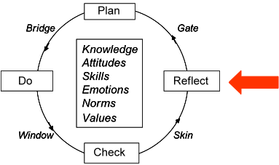

Juch distinguishes four learning styles, or conversely, learning barriers:
- The Gate: concretising intentions into plans;
- The Bridge: putting plans into action;
- The Window: picking up experiences and feedback information;
- The Skin: letting experiences and feedback influence frame of reference
Central in Juch’s circle is reflection.
As shown below a professional who is working in the PCDR-cycle on the job, may learn at the same time in action. Reflectiveness allows Lifelong Learning in action on the job.

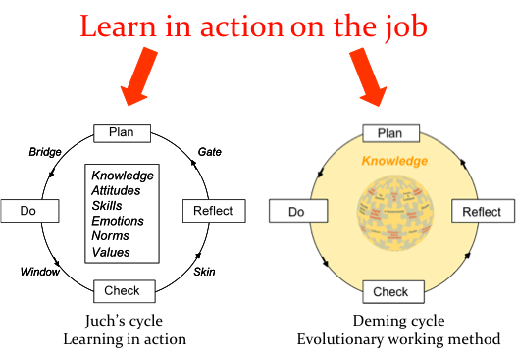

3.3 References
Juch, B. (1983). Personal Development Theory and Practice in Management Training. Chichester: John Wiley.
OECD (2003) The definition and selection of key competencies. Executive Summary. The Definition and Selection of Competencies (DeSeCo) project. www.oecd.org/edu/statistics/deseco (accessed August 2006)
Kendall, Mike & Tom van Weert (2005) The growing importance of lifelong learning with ICT. In: Samways, B. (ed.) (2005) Proceedings of the World Conference Computers in Education 2005. Laxenburg: International Federation for Information Processing.
World Bank (2002) Lifelong Learning in the Global Knowledge Economy: Challenges for Developing Countries. World Bank, Washington D.C. http://www1.worldbank.org/education/pdf/Lifelong%20Learning_GKE.pdf, accessed June 2003.

3.4 IFIP Agora literature
Tom van Weert & Raymond Morel (2007) Seoul 2.0 Model. A learning organisation for lifelong learners. IFIP Agora Initiative, Laxenburg. http://www.ifip-tc3.net/article.php3?id_article=146
Tom van Weert & Mike Kendall (2007) How to create a lifelong learning environment. IFIP Agora Initiative, Laxenburg. http://www.ifip-tc3.net/article.php3?id_article=146

4. How to educate knowledge workers

4.1 Digital Literacy and e-inclusion in schools
Seminar contribution: Lampros Stergioulas
The pursuit of Digital Literacy and e-Inclusion in Schools / The e-Start project - Curriculum Development and -Teacher Education

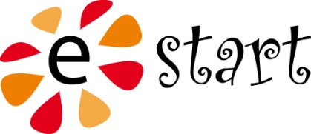

Digital Literacy: Basic characteristics
Refers not only to the skills of operating and using a wide range of information and communication technological environments (hardware devices and software platforms), but also to the processes of “reading” and “understanding” the contents of these technological environments, as well as the processes of “creating” and “writing” such contents (information, services, resources, etc). Even though is often described in comparison to the umbrella term “ICT literacy”, which is broader than both computer and network literacy, it appears to contain it.
DL is indisputably related to media literacy, because it addresses social, cultural, human and ethical issues related to digital citizenship, emphasizes the influential role of digital mass media of expression and considers their attributes, merits and limitations.
The contemporary endorsement of digital literacy is perceived as an act in response to the emergence and broadening of the “digital divide”, a complex phenomenon involving a web of inter-related cultural and socio-economic factors.
Digital Divide: a concept in permanent flux
Contemporary notions suggest that:
- Emphasis on the access factor alone is rather deterministic
- Both the “digital divide” and “access to technology” are hierarchical and not dichotomous concepts
- The digital divide is simultaneously a projection and an extension of the “social exclusion phenomenon”
- Quality of use of digital technology is dependent on the “economic”, “cultural” and “social capital” that individuals possess and project in their engagement with technology
Factors and indicators of Digital Literacy in schools
DIGITAL LITERACY
- hierarchical concept, existing in a continuum
- is relative (may take different meanings in different cultural and socio-economic contexts)
- development targets contemporary socio-economic problems and prevailing educational conditions involving notions of power, dominant ideology and hegemonic culture.
ACCESS (and USE)
- access to computers at school
- Ownership of digital equipment and resources at home
- ….
- “Digital Divide” in EU is often perceived in terms of Access and Use (see i2010 report of EC)
RELEVANCE
- “digital incentives” for life after schooling
- children’s “lifestyle choices”
- motivation, interest and attitude towards digital culture
- perceptions of usefulness and value of digital technology in everyday life
SOCIAL RESOURCE NETWORKS
- pupils’ and teachers’ membership in different social communities
- differentiated forms of culture
Network of networks
The creation and development of a EU-wide “network of networks” of academics, researchers and educational representatives.
Collect, review and analyze the contents of established and implemented educational frameworks and/or curricula related to digital literacy
Collect, review and analyze the contextual and content characteristics of national teacher training and teacher education actions related to the development of digital literacy
Identify critical factors, indicators and conditions that may promote or hinder the pursuit of digital literacy in compulsory education
On the basis of the previous knowledge, start building consensus around a central core of methodologies and values
HOW TO GET INVOLVED
Member registration (free) at www.estart-net.org
Most important barrier
The promotion of a “new ethos” towards the process of designing and implementing educational policy and the endorsement of the idea of syn-praxis and unity within divergence, which:
- Requires transformative changes in the processes of designing and developing the aims, the contents and the organization of education
- Disputes the structures, the regulatory settings, and the contents of a centralized education

4.2 Evolving Discourses and Practices of Lifelong Learning
Seminar contribution: Carolyn Medel-Anonuevo

Evolving Discourses and Practices of Lifelong Learning: Some issues and challenges

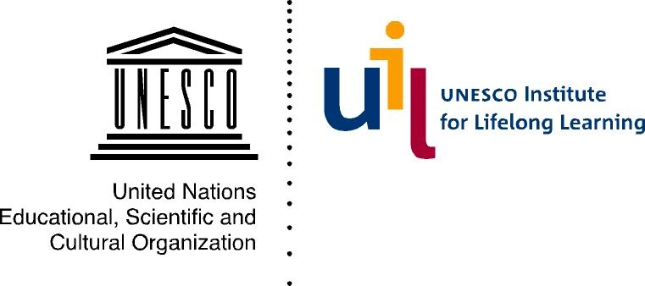
Discourses on Lifelong Learning
a. As a common sense principle of learning throughout life
b. Rooted in tradition/culture
c. As a political discourse
- Nyerere- learning about anything that helps us to understand the environment we live in.... (1969)
- Ho Chi Minh- we have to learn and work throughout life...
- South Africa- all individuals should have access to lifelong education and training irrespective of race,class,gender, creed or age (African National Congress-1994)
d. As an economic discourse
e. As an educational discourse
- Faure report (1972)
- R. H. Dave (1976) Foundations of Lifelong Education
- OECD (1973) Recurrent education: a strategy for Lifelong Learning
- Learning to be, Learning to do, Learning to know, Learning to live together: Lifelong Learning critical for survival in the 21st century
Education context
- 774 million are considered illiterate, majority are women
- 80 million children have no access to schools
- Irrelevance of schools, less budget
- Young and old are needing new skills and knowledge (eg cope with HIV, conflicts)
- Many are vulnerable and excluded
Context of globalisation
- Rapid change in technology-> need to update skills and knowledge
- Different kinds of skills needed across the globe
- ICTs-->information explosion->how to deal with information
- Brings people and cultures together ->> how to live together
- Knowledge based economies →Knowledge Society→ competition

Operationalisation
- As policy (national and regional)
- As bridging the formal and non-formal education
- As providing learning opportunities for all
Key issues
- Conceptual issues
- Policy divide
- Purpose of LLL
- Coherence of LLL policy
- Appropriate structure
- Allocation of resources
Challenges
Clarifying and integrating LLL discourses across the Discourse Divide:
- Uneveness of understanding of discourse
- Economistic versus humane and transformatory
- Many different systems of education
- Fragmented way of looking at educational discourses

4.3 Educating knowledge workers
Seminar contribution: Tom van Weert
Criteria for lifelong learning environments (Addis Abeba 2.0)
Criterium I: Authentic problems
Criterium II: Authentic knowledge work
Criterium III: Self-direction through integrated critical reflection
Criterium IV: Concentric career in working and learning
Criterium V: Integrated ICT

Criterium I: Authentic problems
According to Mulder (1997) complexity of a learning task may be characterised in four dimensions: the expertise of the actor, the complexity of the task at hand, the level of support and the external importance of the results. It is “common wisdom” in education that expertise has to be built up by going from the less to the more complex, from a high level of support to lower levels, and from simple, educational tasks to more complex, real-life tasks. However, recent research shows that this approach undercuts motivation and transfer. It is important to let students work in authentic situations with authentic problems as soon as possible (Kearsly & Shneiderman 1999). The addressed problems should be in the zone of nearest development of the students, both with respect to their level of professional competence and their level of knowledge work competence.
“In direct contrast to the academic approach, practical problems tend to be characterized by: the key roles of problem recognition and definition, the ill-defined nature of the problem, substantial information seeking, multiple correct solutions, multiple methods of obtaining solutions, the availability of relevant prior experience, and often highly motivating and emotionally involving contingencies” (Sternberg, Wagner & Okagaki 1993, p. 206).
Key differences between the school-based approach and real-life approach have been developed and summarized by Lebow and Wager (1994) (see Table 3.1).
Real-life | In-school
Involves ill-formulated problems and ill-structured conditions | Involves text-book problems and well-structured conditions
Problems are embedded in specific and meaningful context | Problems are largely abstract and de-contextualised
Problems have depth, complexity and duration | Problems lack depth, complexity and duration
Involves cooperative relations and shared consequences | Involves competitive relations and individual assessment
Problems are perceived as real and worth solving | Problems typically seem artificial with low relevance for students
Table 3.1 Real-life versus in-school problem solving (Lebow & Wager 1994)

Herrington, Oliver, and Reeves (2004) have defined ten design principles for developing and evaluating authentic activity-based learning environments. In adapted form these are:
- Problems are authentic and have real-world relevance: the problem context is authentic and there is a real-world problem owner; the student has a real-world motivation for wanting to solve the problem.
- Problems are ill defined, requiring problem analysis and definition of tasks and sub-tasks.
- Problems are integrated and across different subject areas; solutions extend beyond domain-specific outcomes.
- Problems require students to reflect and involve beliefs and values.
- Problems need polished products valuable in their own right, rather than as preparation for something else.
- Problems allow competing solutions and diversity of outcomes.
- Problems require students to analyse from different perspectives, using a variety of resources.
- Problems require complex tasks to be performed over a sustained period by a team of students using a variety of resources.
- A problem solution can only be realised by collaborating.
- Problem solving and assessment are seamlessly integrated.

Criterium II: Authentic knowledge work
For knowledge work to be authentic students/professionals need to perform real-life professional tasks that logically are needed to solve the authentic problem. These tasks will be grouped in professional roles such as environmental engineer, software engineer, communication expert, etc.
In authentic knowledge work student also need to perform real-life knowledge work tasks that are grouped into the knowledge work roles:
- Researcher (researching conceptual models);
- Designer (designing using domain knowledge);
- Adviser (interacting);
- Organiser (organising activities).

The professional and knowledge work tasks are directed and orchestrated via an authentic problem solving method that:
- Is based on the PDCR-working cycle
- Provides for extensive problem analysis and planning,
- Explicitly provides means for establishing contextual validity (validation),
- Explicitly provides means for establishing quality (reviewing),
- Requires mobilisation and application of available knowledge,
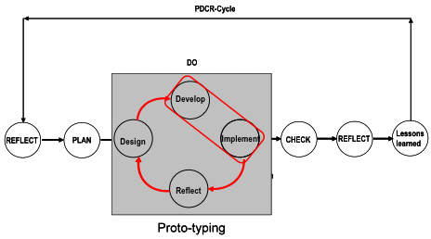
- Combines problem solving with competence development (learning) and knowledge development (research).
Quality of professional and knowledge work practice is enhanced by applying explicit criteria of quality/performance that are standards in real-life.
Quality criteria
To actions that a knowledge worker performs, the following criteria apply:
The actions are performed in a professional way:
- Result effective (lead to the specified result)
- Knowledge effective (effective use is made of available knowledge)
- Efficient (with respect to time, resources and energy invested)
- Responsible (sustainable, safe and ethical)
The actions are performed in a transparent way:
- Complete (follow the agreed working method)
- Reconstructable (can at a later time still be followed)
- Communcative (are communicated in clear way)

The actions are performed in a logical way:
- Sound reasoning (the actions are based on sound reasoning)
- Relevant (no irrelevant arguments are used)

The actions are performed in a reliable way:
- Flawless (not influenced by flaws in tools or techniques used)
- Timeless (not influenced by the moment in time when they are performed)
- Pressureless (not influenced by external pressures from persons or organisations)

To results that a knowledge worker produces, the following criteria apply:
The results delivered are adequate:
- Effective (the result indeed is a solution to the problem posed; sub-problems have been effectively solved)
- Integrated (the result fits the context in which it is to be used)
- Durable (the result is safe, ethical and sustainable in time)

The results delivered are valid:
- Accepted (the result is accepted in the context where it is to be used)
- Acceptable (the result is acceptable in the wider problem domain)
- Underpinned (the result is based on sound conceptual reasoning)
- Explained (the result has been logically explained)

Criterium III: Self-direction through integrated critical reflection
Critical reflection is a pre-condition for quality ánd for learning. Therefore a suitable learning environment must invite cricitical reflection, and specifically explicit reflection. The authentic problem solving method therefore needs explicit activities for:
- ‘reflection in social interaction’ (validation)
- ‘critical reflection’ (review)
- ‘critical self-reflection’ (human resource review)
Also, objective quality criteria for process, results and personal performance are needed.
A learning environment that stimulates critical reflection has the following characteristics (adapted from van Woerkom 2003; p. 74-75 and Anderson 1997):
- Learning climate:
  - collective reflection for strategic learning,
  - contacts across the learning environment,
  - learning from the experience of others and
  - tolerance for other opinions;
- Governing values that include:
- valid information;
- free and informed choice;
- internal commitment;
- Strategies that include:
- sharing control;
- participation in design and implementation of action.
- Operationalisations that include:
- attribution and evaluation illustrated with relatively directly observable data;
- surfacing conflicting views;
- encouraging public testing of evaluations;
- participation in innovation and decision processes;
- transparency and integral communication by the management.
This implies that there will be no critical reflection without self-direction. This self-direction is not random however; it is embedded in the authentic problem solving method used.
Criterium IV: Concentric career in working and learning
Students get the opportunity to develop a professional career, moving their performance from reproductive, via executive and tactical to strategic. The learning environment must allow students to develop such a career through different levels of performance.
Criterium V: Integrated ICT
ICT is integrated in professional and knowledge work: as a tool for analysis, design and creation, for process and team management, for communication and for knowledge management. Essential characteristic of these tools is that they enhance performance, that they contribute to process and result. In the learning environment the same should be true: ICT should have those functionalities that are needed and appreciated by the students.
The educational role of ICT is changing. “There is a paradigm shift in Informatics in general and in technologies enhancing human learning in particular. The debate between the “evolutionaries” – those that wish to optimize and refine current approaches – and the “revolutionaries” – those that support a fundamental change of approach – is quite actual. Within the Internet communities, the debate is hidden behind the words “semantic WEB” versus “semantic Grid”; within educational technologists between “content/resource centred” and “conversation centred” e-learning, or either between “teaching” and “pedagogy” on the one side, and “learning” and “communities of practice” on the other. In general, in Informatics, the shift from a product-page oriented to a service-conversation oriented view may possibly impact most if not all the foreseen applications, in e-learning, but also in e-science, e-democracy, e-commerce, e-health, etc.“. (Ritrovato 2005)
References
Anderson, J. & T. J. van Weert (eds.) (2002) Information and Communication Technology in education.A curriculum for schools and programme for teacher development. UNESCO, Division of Higher Education, Paris.
Herrington, J., R. Oliver & T. C. Reeves (2002) Patterns of engagement in authentic online learning environments. In: A. Williamson, C. Gunn, A. Young, & T. Clear. (eds.), Proceedings of the 19th Annual Conference of the Australian Society for Computers in Learning in Tertiary Education (ASCILITE). Auckland: UNITEC, pp. 279-286.
Kearsley, G. & Shneiderman, B. (1998). Engagement theory: A framework for technology-based teaching and learning. Educational Technology, 38, 20-23
Lebow, D., & Wager, W.W. (1994). Authentic activity as a model for appropriate learning activity: Implications for emerging instructional technologies. Canadian Journal of Educational Communication, 23(3), 231-144.
Mulder, R.H. (1997). Leren ondernemen: ontwerpen van praktijkleersituaties voor het beroepsonderwijs. Academisch proefschrift. Rotterdam: Erasmus Universiteit.
Ritrovato, P. et. al. (Eds.) (2005) Towards the Learning Grid - Advances in Human Learning Services. Frontiers in Artificial Intelligence and Applications, 127. ISBN: 1-58603-534-7,
http://www.elegi.org/ (accessed November 2005)
Sternberg, R.J., R. K. Wagner & L. Okagaki (1993) Practical intelligence: The nature and role of tacit knowledge in work and at school. In: Puckett, J. M. & H.W. Reese (eds.) Mechanisms of everyday cognition. Lawrence Erlbaum Associates, Hillsdale, NJ, pp. 205-227.
Woerkom, M. van (2003) Critical reflection at work, Bridging individual and organisational learning, Universiteit Twente.

5. Organisations in the knowledge society
Seminar contribution: Tom van Weert
Lifelong Learning of organisations (Seoul 2.0)
Organisations that aim to be successful in an economy and society driven by e-change are also trying to hit a moving target. Therefore also for learning organisations an evolutionary approach is sensible, for example working in an adapted Deming Cycle: REFLECT-PLAN projects-DO projects-CHECK projects-REFLECT.

5.1 Success factors
The fundamental success factors of learning organisations are derived from the concepts of excellence that are part of the EFQM Excellence Model (EFQM 2003). Technology support is added as an enabling success factor.
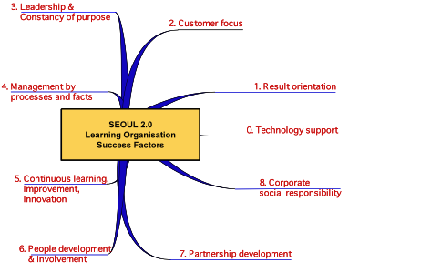

Technology support
Learning organisations are Web-enterprise or agile organisations (Campbell 1997). ICT-support helps them to establish temporary networks of experts working in a specific field or on a specific topic: spatially dispersed and temporarily flexible cultural communities where knowledge management and the sharing of information among partners are essential. Supporting ICT applications are: local and wide area networks, electronic data interchange, Internet, intranets, groupware systems, knowledge-based technology and other applications of artificial intelligence, such as intelligent agents.
Benefits: agile and flexible organisation, improved effectiveness and efficiency, increased competitiveness
Results Orientation
In the fast changing environment that is today’s world, learning organisations are able to deliver results that meet stakeholders and customers needs and expectations that change, often frequently and quickly. Learning organisations are agile, flexible and responsive.
Benefits: added value, sustainable success, understanding of the current and future requirements for performance, alignment and focus throughout the organisation.
Customer Focus
Learning organisations know and intimately understand their customers. They understand that customers are the final arbiters of product and service quality. They also understand that they need a clear focus on the needs and expectations of both existing and potential customers. They are responsive to those customers’ present needs and expectations.
Benefits: strong customer loyalty and retention, enhanced market share, sustained success for the organisation, motivated professionals in the organisation, understanding of competitive advantage.
Leadership and Constancy of Purpose
Excellent performance is driving and inspiring the professionals in a learning organisation. Leaders in the organisation display both role model behaviour and result performance. They lead by example, recognising their stakeholders, professionals and customers. They work with them on joint improvement activities. Learning organisations are managed on the basis of results and process performance.
Benefits: clarity of purpose and direction, a clear identity, a shared set of values and ethics, consistent role model behaviour, confidence even in turbulent and changing times.
Management by Processes and Results
Methodical implementation of policies, strategies, objectives and plans is enabled and assured through a clear and integrated set of work processes. Decisions are based on factual results meeting stakeholder, professional and customer needs and on reliable information relating to current and projected performance, and work process quality,
Benefits: maximised effectiveness and efficiency, effective and realistic decision-making, effective management of risk, enhanced confidence of stakeholders and professionals.
Continuous Learning, Improvement and Innovation
Learning organisations continuously learn, both from their own activities and performance and from that of others. They capture and share the knowledge of their professionals in order to maximise learning across and within the organisation.
Benefits: improved value generation, improved effectiveness and efficiency, increased competitiveness, innovation in results and services, knowledge capture and sharing, organisational agility.

5.2 Maturity levels
Within the IFIP Secondary Curriculum a model was developed for the maturity of school organisations with respect to ICT (Anderson & van Weert 2002) with four stages: Emerging, Applying, Integrating and Transforming. This generic model can also be used to decide how mature a particular organisation is as a learning organisation. Using the following stages:
Emerging
This approach is linked with an organisation in the beginning stages of learning organisation development. In this initial phase, leadership and professionals are just starting to explore the possibilities and consequences of new ways of organising work. The organisation is still firmly grounded in traditional practice.
Applying
This approach is linked with an organisation in which new understanding of the contribution of new ways of organising and working has developed. In this approach leadership and professionals use new approaches for traditional tasks. Leadership is still firmly traditional.
Integrating
This approach is linked with an organisation that now is applying new ways of working both in management, administration and in primary activities. Leadership and professionals explore new ways to enhance their personal productivity and professional practice.
Transforming
This approach is linked with an organisation that has used the experiences to creatively rethink and renew the own organisation. Learning and knowledge production become an integral though invisible part of daily personal productivity and professional practice.
Critical areas of development are:
- Technology support
- Results Orientation
- Customer Focus
- Leadership and Constancy of Purpose
- Management by Processes and Facts
- Continuous Learning, Innovation and Improvement
- People Development and Involvement
- Partnership Development
- Corporate Social Responsibility

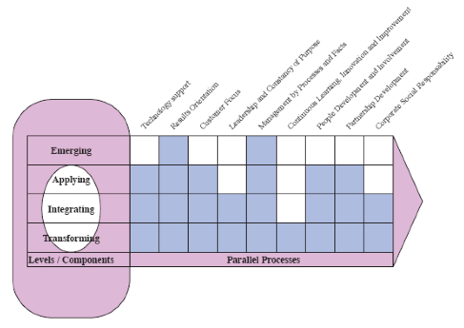

Maturity as learning organisation of a particular organisation

Tom van Weert & Raymond Morel (2007) Seoul 2.0 Model. A learning organisation for lifelong learners. IFIP Agora Initiative, Laxenburg. http://www.ifip-tc3.net/article.php3?id_article=146

5.3 Lifelong learning of organisations
Lifelong Learning of organisations in the knowledge society is conceptualised as learning from projects.
Atelier-Studio concept
The working method of “REFLECT-PLAN projects-DO projects-CHECK projects-REFLECT” is detailed in the Atelier-Studio Concept of the Seoul 2.0 model.
On the local context level Studios are directed at real-world creation of practical instances of e-Education for Lifelong Learning in different areas of computer science education and educational use of ICT. Studios will provide contextual solutions, suitable for the cultural, social and economic context and for the special demands of the specific subject area of Lifelong Learning.
On a generalizing and co-ordinating level an Atelier is mutually linked with the studios to:
- generate generic knowledge based on the experiences of the different studios.
- this knowledge can be applied in local ‘Studio’s’ where Lifelong Learning pilot implementations are realised.
- the generic educational Lifelong Learning model developed in the Atelier will be evaluated and improved in a process of critical review of the pilot implementations
- concurrently improve practice of Lifelong Learning in the local Studios.
Complex subject areas may have several ateliers to co-ordinate their activities. Thus a hierarchical structure of specific, topic related and more general ateliers may emerge.

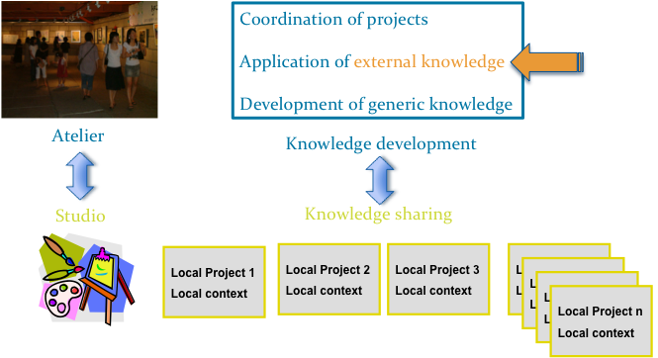

Essential element is the combination of knowledge development and knowledge sharing:
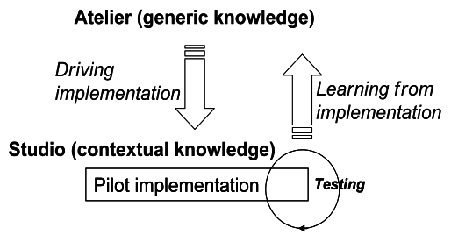

IFIP Agora Studios are local projects aimed at enhancing e-competence and knowledge work competence of professionals and students; the projects take account of local needs and local resources, such as level of access to ICT and e-readiness of the local society.
IFIP Agora Ateliers are (International) review groups, where contextual local efforts in Studios are connected to each other contributing in a synergetic way to generic shared knowledge about Lifelong Learning; the generic knowledge in its turn is driving the local projects

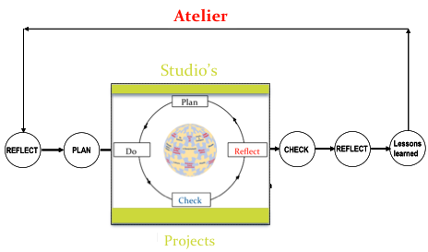

5.4 How to promote lifelong learning in educational organisations

What do teachers say What is behind?
I have no time, too much to do NO LEADERSHIP & NO MOTIVATION
I do not know what the goal is I FEEL INSECURE
There is no money NO PRIORITY
I have a problem I want to solve AFFORDANCE AND MOTIVATION
What should I learn? I FEEL INSECURE
Yes, I already have learned for15 years NO CHALLENGE, NO MOTIVATION
No, I do not want to learn, that gives obligations NO LEADERSHIP & NO MOTIVATION
The organisation is not flexible, not helping NO LEADERSHIP & NO MOTIVATION

How to overcome barriers?
- Learn locally in safe projects by doing things in a different way (bottom-up)
- The projects deal with the real problems, problems that count
- Use a Deming Cycle based problem solving approach with explicit CHECKs on where you are (validity)
- Improve and reward quality of work and results through explicit REFLECTION activities
- Create an Atelier of professionals for REFLECTION on the projects

Don’ts
- Work in very large top-down projects
- Work on irrelvant problems that have more to do with bureaucracy then learning
- Use a project management method to severly control project time
- Reward quantity of results and financial gain achieved
- Let professionals grumble and complain at the coffee machine
Studio projects
- Have Real-world relevance
- Are ill defined, requiring definition of tasks and sub-tasks
- Involve complex tasks over a sustained period of time
- Allow different perspectives on tasks, a variety of resources
- Offer opportunity to collaborate
- Neccescitate opportunities to reflect, involving beliefs and values
- Are integrated and across different areas
- Are seamlessly integrated with assessment
- Yield polished products valuable in their own right
- Allow competing solutions and diversity of outcomes

6. Co-operation projects: Case studies

6.1 New AGORA atelier on basic assumptions for education process integrated with ICT and LLL
Seminar contribution: Barbara Kędzierska
The role of universities in lifelong learning process (polish context)
Today and Tomorrow of the University
Today | Tomorrow
students = young people | students = youngs & adults
students have no professional experience | students often have considerable professional experience
teachers know what the student is supposed to learn | students know what the teacher is supposed to teach them
teaching of basics | teaching of solving problems
stationary teaching - the student is studying at one university only | distance teaching - the student is studying at many universities at the same time

Lifelong Learning
- Focuses on learner
- Applies to formal, non-formal and incidental forms of education
- It is not a combination of formal education and professional training but a lifestyle
- Joins individual’s personal development with company’s inner development
- Basic foundation for the concept od continuing education is not so much the necessity of developing but lifelong learning
- Emphasises the competence as a condition of individual and social development
- Forces the redefinition of the basic aims and methods of their realization for formal education
- Assumes the modularity of the system of learning and perfecting
Crucial competencies
- communicating in mother’s tongue
- communicating in foreign languages
- math competences and basic science-technological competences
- computer competences
- ability of learning
- interpersonal, intercultural and social competences, as well as civil competences
- enterprise
- culture expression
Document worked out by the European Communities Commission, the document Crucial Competences in learning during the entire life - European referential frames. This document is an annex to the Conclusion of the European Communities Commission concerning a Recommendation of the European Parliament - COM(2005)548 final
Looking to the Future
In the context of university education, we should neverending answer the questions:
- Who ? – PROFILE OF THE TEACHER
- What ? – RATIONAL SELECTION OF CONTENT
- How TO TEACH ? – SELECTION OF THE PROPER METHODOLOGY
- Why ? – MOTIVATION
Proposal
To create in the structure of AGORA new atelier with its main goal – to work out basic assumptions for education process integrated with ICT and LLL, f.e.:
- what does it mean today „modern” education process?
- if not transmission of knowledge, so WHAT?
- tests assess the fact-knowledge, not competence, so what is proper way of assessing of competence of students?
- new ICT tools are not effective for old forms and methods, so, what form and method is optimum today? (especially for formal education)

6.2 Partnership in Malopolska for The Lifelong Learning
Seminar contribution: Malgorzata Dudziak
Project co-financed by the European Union from the European Social Fund and the national budget in the framework of the Integrated Operational Programme for Regional Development (IOPRD)
Aim
STRENGTHENING OF COOPERATION BETWEEN INSTITUTIONS CONNECTED WITH THE LABOUR MARKET, EDUCATION AND TRAINING, IN ORDER TO PROMOTE AND DEVELOP THE LIFELONG LEARNING IDEA IN MALOPOLSKA
- Partners:
Department of Education and Sport (UMWM)
- Department of Information Society (UMWM)
- Education Office in Cracow
- PRAO- Pôle Rhône-Alpes de l’Orientation
Malopolska Agreement for LLL Idea
- Determine of principles and way of cooperation between labour market institutions in Region for lifelong learning,
- Guidelines for development and promotion LLL in Malopolska

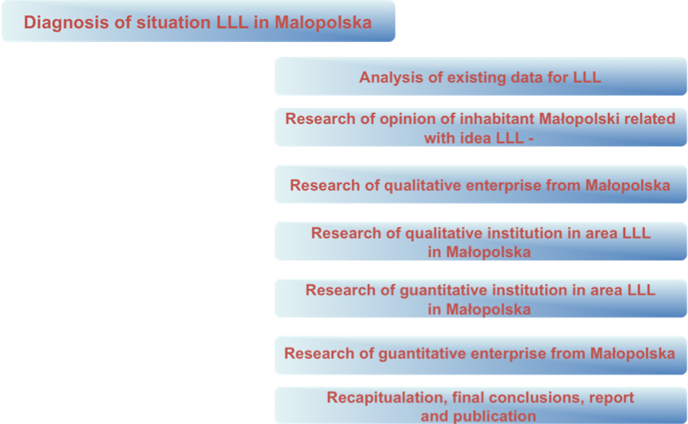

6.3 The role of career guidance in Lifelong Learning

Seminar contribution: Ewa Bodzinska-Guzik
The situation in the Małopolska region
based on expertise for Development Strategy for the Małopolska region 2007-2013)
- Citizens are more aware of investing in their development
- Well – developed educational infrastructure -34 academic institutions in Małopolska
- Citizens are increasingly interested in improving their education – increase in number of people with higher level of education (every –10th of citizens has a higher degree)
- The number of students who work and study increase
Strong points
- Thanks to ESF more working and unemployed people can get access to Vocational Educational Training
- Public employment service and education sector have professional staff (about 70 guides in labour offices)
- The lifelong learning system is being developed in the Region
- The institutions in the area of lifelong learning operate no longer in isolation
Weak points
- The number of public institutions providing education and training to adults as well as number of people using them is rather low compared to other regions(8th place in the country)
- There is an information gap concerning lifelong learning outside the school system, the information should be gather in data base
- Employers are not satisfied with proposals of trainig providers – proposals are not based on reliable surveys
- There is not enough carreer counsellers in schools(40 counsellers in about 700 schools )
- In communes there are difficulties in access to information about guidance and VET services
- Service – New approach to life-long planning vocational development
- Vocational and labour market information –
  - group and individual
  - Individual vocational counselling
  - group vocational counselling
- Educational Method
- Inspiration Course
- Parachute
Activating workshops
- Studying vocational potential
- Methods of job seeking
- How to prepare application documents?
International cooperation
- with PRAO (Pole Rhone-Alpes de l’Orientation):
- Cooperation within the project „Partnership in Małopolska for the Lifelong Learning”
(Project co-financed by the European Union from the European Social Found and the national budget in the framework of the Integrated Operational Programme for the Regional Development)
One of the aims: Raising up the qualifications of professionals in regional institutions (e-learning, workshops, seminars, visits)

- Małopolska as a partner in the project „AQOR”” (Leonardo da Vinci Programme)
One of the aims: Strengthening the quality in lifelong guidance
Raising up the qualifications of professionals in regional institutions:
E-learning course for career guides, education and job advisors representing different institutions from the labour market, education and training
Aims:
- To complete the knowledge in area of information management, trends on labour market and education
- Gaining the ability to use modern tools of communication
- Gaining the ability to use different source of communication
- Gaining the ability to look for the useful information
- Gaining the ability to run different project in field of guidance and education
- Knowing e-learning method in order to promote it
Recommendations for improving the quality of lifelong guidance
- Common definition of guidance
- Addressing the offer to citizens’ needs
- Sharing methods and tools
- Developing the network of institutions providing guidance service
- Raising up the qualifications of the professional guides
- Providing quality
Results for Małopolska
- Providing the knowledge about the tools for measuring the quality of the lifelong guidance service
- Working out the quality indicators in Małopolska Region
- Strengthening the quality of he guidance service as a result of the development of service and practices of professionals as well as development of the network
- Implementing the system of quality in regional institutions

6.4 eSchool: New Technology, New Learning

Seminar contribution: Maciej M. Sysło
Recently, we run in-service course for teachers on: distance education (supported by EU) using: e-learning approach, methodology, tools to prepare teachers for: LLL

Access to technology is today not restricted to a physical place
New technology in education – hardware
- laptop, tablet – mobile computers, mobile phone
- Interactive White Board
- Voting (testing) system
- Wireless access to the net
New technology in education – software
- CMS: Moodle
- LMS: Fronter
- e-portfolio – personal archives, reflective comments
New technology in education
Information Technology (IT)
- First: as a subject – students learn IT
- then: IT as education technology – supporting other subjects and activities
- IT integrated with other subjects and disciplines – as a part of almost all disciplines
moreover: IT stimulates development of other disciplines which incorporate changes in IT
Model for ICT development
Dynamic process of incorporating technology into education systems. Four stages:
- Emerging stage – the beginning stage of IT development when schools get new technology; interests in IT
- Applying stage – the use of IT in traditional settings, curriculum, classes; IT is mainly added
- Integration stage – IT integrated, embedded into subjects, activities, related to real world use
- Transformation stage – rethinking and renewing education and school role and organization; development of IT professions
This model is dynamic and applies to each new technology
Model for e-learning
Four stages with regard to teachers, students and schools development:
- Emerging stage, our course for teachers, teachers as students in distance education using e-learning
- Applying stage, teachers use what they have learnt with their students; this is the emerging stage for students
- Integration stage: teachers design a course integrating traditional approach with e-learning tools and methods (blended approach)
- Transformation stage: school as an element of LLL in the society, applying e-learning in distance education

New technology and new learning
Old question: how to prepare for the future? – difficult to answer since we do not know the future, especialy related to IT, instead:
- teach how to learn – do not: exclude, e-exclude, divide and teach how to built ones own learning (e-portfolio?), and prepare for:
- LLL – built „a system” of learners in addition to (or in the place of?) the traditional system
New informatics and ICT technology
Development of ideas how to prepare in new information and communication technologies, the scope of preparation:
- computer literacy – basic computer and net skills
- fluency with IT – additional skills and competencies: basic informatics ideas and intellectual abilities (abstract thinking)
- computational thinking – competencies built on the power and limits of computing processes; 3R (reading, writing, arithmetic) + IT → 3R + computational thinking
International Conference
INFORMATICS in SECONDARY SCHOOLS, EVOLUTION and PERSPECTIVES
http://www.rsei.uni.torun.pl/issep/, 1 – 4 Lipca, 2008; UMK, Toruń

6.5 E-learning in Life-Long Learning. Academic Approach

Seminar contribution: Jerzy M. Mischke
What is e-learning?
- E-learning (EL) is a way of learning supported with technical means by remote teacher.
- Person to person e-contact and learning process organization are the key words.
What is b-learning?
B-learning (BL) combines distance learning (DL) with F2F tuition, optimizing study efficiency and expenditures.
Why we speak so much about LLL?
Live Long Learning has been known ever since human being existed, so why we are speaking so much about it?
- Individual approach to LLL appears to be not enough.
- An institutional approach to LLL is necessary.
- Call for new competence appears suddenly and have to be met promptly.
- There is only a short time available to learn what is needed.
- There are to many peoples seeking an improvement of ability.
2 models of learning
- Academic model of learning describe education process aiming at development of fairly large professional knowledge. Mainly distance (DL) and blended learning (BL)
- Corporate model of training is tailored to teach of proper activity – a skill in particular. CBL, WBL, but either DL and BL.
Just enough, Just for me, Just in time
- Just enough means not more then is necessary for reaching the course or study target.
- Just for me means dedicated, personalized course or study to meet individual prerequisite and target. Many learners with differences in personal skill and knowledge requires many different courses or contents of study.
- Just in time means to prepare in advance a lot of courses of very different kinds and grade to deliver them promptly on demand even for a few learners – some time at fare places.
How to deliver?
- Library of extensive kinds of courses has to be build in advance.
- Curricula of regular study have to be adapted to forecasted future LLL activity of students.
- The university has to be prepared to deliver demanded course at once and for very small group of user (even for one learner only).
To arrange it some additional funds have to be available.
Strategy for LLL
E-learning allows to:
- prepare in advance large numbers of Reusable Learning Objects (RLO),
- combine easy RLO together into LLL courses or modules on demand,
- deliver courses or study at distance and asynchronous mode,
- in extreme allows a course delivery to individual learner.
- E-learning is the most frequently used for training of some skills (in service, technology, or products).
- F2F training is usually the best way to learn behavior (personal communication etc).
- B-learning is the most useful in study.
What is needed?
- Good will of university’s staff.
- LCMS/LMS software.
- Library (database) of RLO, courses and modules.
- Team of professionals to design and deliver LLL courses.
- Team of professionals for teacher’s support

6.6 Citizen education in lifelong learning – Polish context
Seminar contribution: Magdalena Przerszlo
Lifelong learning
Citizenship is the area of human functioning, which requires constant gaining of knowledge and new competence
- There is the next task for the school, which should provide students not only with a proper level of substantial knowledge and didactic tools for further education, but first and foremost instill the idea of lifelong education essential for developing the ability to compromise and look for understanding, actively undertake tasks, important from the social point of view, which will serve to realize personal and common aims.
- Civic education is becoming a very important area of lifelong education, which constitutes the basis of responsible and solidary society, which respects fundamental rights of each person.
Background
A historic legacy coded in Polish outlook on life is a specific, separated perception of patriotism, identified in XIX century with national identity and citizenship
- Something like double morality was created. Functioning in the times of annexation of Poland by foreign countries required - for maintaing national identity - the separation of what was patriotic, Polish from what was civic – state, not Polish..
- This specific division into We – ordinary people, honest, not governing, not dealing with politics and They – priviliged people, bad, corrupted, governing and politicians related with power is the basis of contemporary perception of a nation and citizenship. The specific division into We and They lasts until now..
- Polish ability to organize themselves during the period of annexation, conspiration or totalitarian country did not result from the political community, but a national one. In connection with this, when in free Poland a national factor ceased to play a decisive role it turned out that the Polish could not communicate with one another. International and inner situation of Poland and the processes taking place in the global scale set the tasks that significantly go beyond the cultural community. That is why it is essential to create the “ political nation”.
New media influence politics
We can mention Spain here. This is where in 2003 terrorists used cell phones to make the bombs explode on the trains
- Then, thousands of people, using cell phones convoced the mass meeting in front of the building of People’s Party to abolish the government of the prime minister Aznar. On the day of the meeting operators noted forty as much smses as usual.
- Then, thousands of people, using cell phones convoced the mass meeting in front of the building of People’s Party to abolish the government of the prime minister Aznar. On the day of the meeting operators noted forty as much smses as usual.
- And recently, during the elections in Byelorus, the opposionists received the same sms with threats. Then, by the same means, the opponents of Łukaszenko convoced themselves for the opposition meetings
People, who mobilize themselves by the means of telephones are called smartmobs. The kind of democracy they entail is called adhocracy (ad hoc now, at once).
The citizen informing himself can for example use the Internet search engines effectively.
- The Citizen Communicating is the Citizen Informing Himself, who moreover can communicate with other people via the electronic way. The aims of this communication can be both professional and personal and people, with whom the citizen communicates, can be the representatives of different cultures.
- The Citizen Learning Himself is the Citizen Communicating, who gains knowledge which determines the quality of professional and private life, using tele-information tools for this aim. For example, a Citizen Learning Himself can specify his current and strategic information needs, which can be satisfied thanks to the electronic sources, which are known to him.
- The Citizen Creating is the Citizen Learning Himself, who can create products and digital services which are used to satisfy the needs of the Citizens Informing Themselves, Communicating and Learning Themselves.
Creating civil attitudes
Civil education
A civil education in self-government school. This is one of the programmes that is best estimated by teachers who teach knowledge about society in high school:
- awarded by the Minister of Education
- prepares to civil activity
- creates pro-social attitudes
- awakens moral sensitivity
- it is interesting, wise and attractive for students
Traces of the past
The programme was started in the academic year 2000/2001. In their surroundings students look for interesting, but neglected buildings, places and other material traces of the past. Then they “ adopt” them, which means they look after them. Through cooperation with authorities and institutions of culture they strive to renovate them in this way restoring forgotten buildings and places.
The young vote
The project conducted since 1995 enables the minor citizens to take part in the most important public events. At schools students organize youth presidential, parliamentary and self-governing elections as well as opinion polls. During academic year 2002/2003 in the students’ opinion poll concerning the access of Poland to European Union “European Union – the young vote” 5000 schools and more than 900 000 students took part. On average, in each of the schools 5 students dedicated themselves to conducting educational lessons and the organization of the youth opinion poll.
The young in Europe
The programme of European education, mainly realized via the Internet, which first and foremost aims at informing young people about the perspectives and opportunities, which gives them the access of Poland to European Union and preparing them to study and work in other countries of European Union.
Being on familiar terms with economy.
CEO ( Citizen Education Centre )compiled the programme and a manual for teaching the subject called the basis of business acumen in post high schools. They contain issues concerning the practical economic education and prepare young people to take reazonable decisions concerning further education, conducting business activity, investment etc.Young Citizens Act Project, which teaches young people how to participate effectively in the public life. Students find out about the problems bothering society, in which they live and choose the project that is particularly important for them. Then they work out its solution and encourage the authorities to introduce their own suggestions. Every year they present in public their activities to the local community and self – government authorities and they participate in all-Polish presentation of youth projects in Warsaw.
“ The future depends on us, but we do not depend on any historic necessity.” Karl Popper

6.7 Examplifying alternative approaches to important aspects of AGORA

Seminar contribution: Anna Kristjansdottir
Assumption 1
Learning is the essence of living! We do not learn for living, we live for learning.
Assumption 2
- General pedagogy for learning, without links to a subject (content of a subject), is an empty shell.
- Subject learning without pedagogical integration is only a technique.
Assumption 3
- Learning takes place in a ”real” environment. That is to be understood: an environment which is ”real” to the learner.
- In present time this refers in particular to a digital environment of information and communication.
Assumption 4
Although school is not always an examplary case of a learning environment - it is nevertheless an environment that reaches ”all” young people and has a developed frame for equality and democracy.
Research questions
- How can students become better aware of their learning as such – to be able to consider learning as an essence of living in all their life and through all their life?
- How can teachers (learn to) function as models for learners – in their work together with students? With work meaning: The repeating spiral: lanning–interactive process–evaluating
- Which obstacles and affordances are there for single teachers for being/becoming models for learners? Which affordances and obstacles are there for larger communities of teachers – for whole schools?
Posing and approaching solutions
- The order in posing of researchs questions was 1, 2, 3.
- The order in approaching solutions to these questions is 3, 2, 1.
Fundamental basis and consideration in new environment
- What has been uttered in the first slides is a part of a wider research and developmental work in Iceland in the period 1987-2002.
- In the period 2002- there has been an opportunity to consolidate important aspects and match to a new environment, Norway - with an inquiring attitude and humble approach.
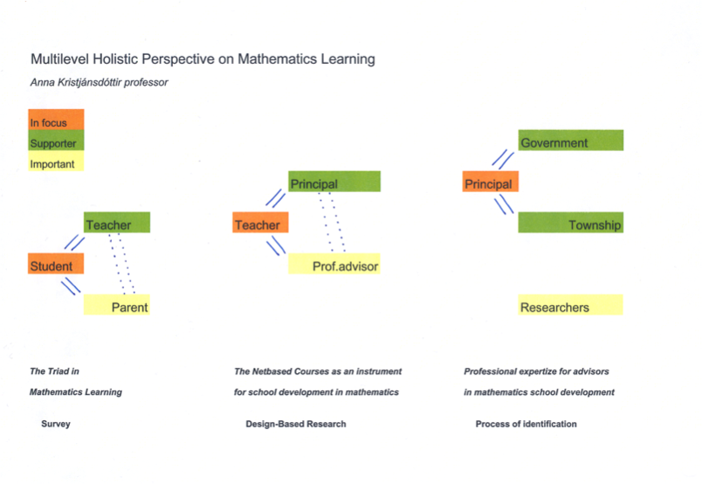

6.8 National computer societies – the role of TC’s

Seminar contribution: Jan Wibe
REFLECTION
Analysis:
It has been recognized that IFIP has problems in satisfying the needs of its stakeholders, the national computer societies.
To quote the managing director of the Norwegian Computer Society: “I feel that IFIP is mainly for it’s own sake and not for the national computer societies. I would like that the TC’s produce more; - f.ex. articles, reports, statistics or publications which could be available for the member societies”.
Approach:
First find topic which is of interest to computer societies, preferably an interest that is within the scope of a computer society special interest group.
Secondly the topic must be interesting to the TC’s involved.
Aim of the project is not for IFIP to provide services, but a cooperation that will create results satisfying the common interest.
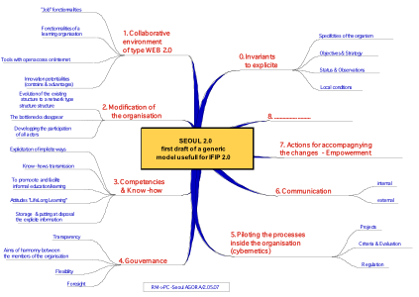

PLAN
Selection of participants in the project:
Select 2 – 3 TC’s to take part in the project. This could be done by TA.
2 – 3 computer societies should also be selected or invited.
The 3 TC’s must work in close cooperation with the national computer societies.
The Ateliers function is to generate generic knowledge based on the implementation experience in different local contexts, called “studios”. In the Atelier the local experiences are brought together to learn from. Generic knowledge developed from these experiences in the Atelier will help the local studio implementation. In this case studio’s would be implementations that national computer societies realise in their national environment. The Atelier can be realised as part of normal IFIP TC activities, bringing together TC-members and national computer society professionals. Basically an Atelier is a community of interest.
(International) review group, where contextual local efforts are connected to each other contributing in a synergetic way to generic shared knowledge about Lifelong Learning; the generic knowledge in its turn is driving the local efforts

6.9 The “Cyber-Teacher” Studio

Seminar contribution: Bernard Cornu
Background
Role of Knowledge; Knowledge based economy
- Accessing Information and Knowledge
- Constructing Knowledge
- Networked Society
- Collective intelligence
- Lifelong Learning
The Cyber-Teacher and the 8 Key Competences for Lifelong Learning
Recommendation of the European Parliament and of the Council on key competences for lifelong learning (18 December 2006):
- Communication in the mother tongue;
- Communication in foreign languages;
- Mathematical competence and basic competences in science and technology;
- Digital competence;
- Learning to learn;
- Social and civic competences;
- Sense of initiative and entrepreneurship;
- Cultural awareness and expression.
Apply the AGORA methodology:
- Studio(s) – local project(s)
- Atelier – International review group (an IFIP WG?)

Seminar contribution: Tom van Weert
The teacher of the 21th century
In the emerging knowledge society teachers will need to develop new competencies to be able to support their students. Below follow examples of tertiary education learning situations for which teachers may have to further develop competencies.
Studio examples
Urban development
A university is building up a partnership with local government (municipal or provincial government). As part of this partnership student teams design scenarios for urban development that the local government can use. In this case an old and monumental factory has to redeveloped for housing and business. At the moment art collectives and community activities have found a home at the premises and the neighborhood does not want to lose these to large scale developments.
The student teams are multidisciplinary (urban planning, environmental studies, etc.). Several teams will develop competing scenarios. They will use ICT for communication and design. They have to deliver validated scenarios to the local government at a time fixed by a large decision making process.
Water management
A university is building up a partnership with a water management board in the region. As part of this partnership student teams design scenarios for managing surplus water. The climate change leads to heavier rainfall and there is a real threat that rivers and canals will overflow. Several scenarios are possible, but most will interfere with local farming, living and recreation.
The student teams are multidisciplinary (water management, water works, environmental studies, etc.). Several teams will develop competing scenarios. They will use ICT for communication and design. They have to deliver validated scenarios to the water management board at a time fixed by a large decision making process.
Energy saving
A university is specializing in practical research on household energy saving. As part of this research student teams have to design competing solutions for household hearing using different resources such as solar heat, geophysical heat pumps, etc. The work of the students is following the method of design research.
The student teams are multidisciplinary, involving technical studies, process control, computing science, etc. Several teams will research alternative They will use ICT for communication, design and realization of their prototypes.
Ateliers
Ateliers on several levels may help the teachers to adequately support their students.
In an atelier on the local level teachers may work together sharing experiences and designing approaches to effective support of the student teams and effective quality assurance (the university cannot afford to deliver defective results and also the presentation of results has to be of professional quality). By reflecting on their actions and results teachers will further develop competencies needed.
In a higher level atelier teachers who are in similar subject areas (e.g. urban development, environmental studies, etc.) may work together sharing experiences and designing approaches to effective support of the student teams and effective quality assurance. By reflecting on their actions and results teachers will further develop competencies needed.
In another higher level atelier teachers may work together who need to support students in design research approaches, again sharing experiences and designing approaches to effective support of the student teams and effective quality assurance. By reflecting on their actions and results teachers will further develop competencies needed.

6.10 Preparing Future Professionals for Lifelong Learning in Higher Education and in Business Academies

Seminar contribution: Johannes Magenheim
Project approach
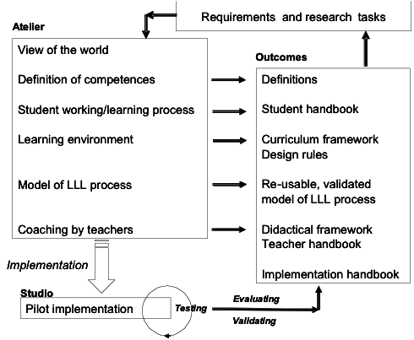
A Case Study: MoKEx - MATURE Project
Mobile Knowledge Experience
Swiss – German Educational and Research Projects
Joint Venture including Universities and Companies
MoKEx I October 2004 – September 2005 (20 students)
MoKEx II October 2005 – September 2006 (20 students)
MoKEx III April 2007 – March 2008 (20 students)
MoKEx IV April 2008 – March 2009 (20 students)
Technical outcomes
- Mobile Delivery Server
- Mobile Access to Learning Objects
- Knowledge Database and Knowledge Bus
with interfaces for authoring processes in e-Learning
- SoA for Single Sign On (EIA)
- MetaXSa, DyoGeneS, Coma
- PLME, OLME
Institutional outcomes
- Industrial partners are provided with prototypes of software-products for professional use
- International co-operation between business and universities leads to a more practice oriented concept of teaching subjects of software-engineering
- The team is composed of interdisciplinary skills. Co-operation between students of different universities and faculties fosters exchange of ideas and diversity of knowledge
- The project team covers the whole spectrum from research to practice (constrains of practice: budget, time, existing structures)
- In comparison with traditional teaching concepts the students obtained a more decisive and managing role in the project
- Teachers got a more advisory role focusing on the project management and supporting the process of knowledge acquisition
- Project assessment methods with Wiki and Blogs edited by the students are used and improved
- Budget paid by industrial partners
Individual outcomes for students
- Project with real-life situations was highly motivating for the students
- Professional competencies: e.g. skills in programming distributed and web-based systems, database management, mobile communication, screen design, project management
- “Continuous and Cooperative Self-qualification and Self-organization (CoCoSS)”; knowledge transfer in a team
- Methodological competencies: in project management, user requirement analysis and presentation skills are applied in the context of a real situation; needs of documentation;
- Social competencies: collaborative learning in a distributed team; using ICT for SD and collaboration; negotiating working conditions;
Extending the concept
Knowledge Maturing Process Model, EU-IP Project MATURE
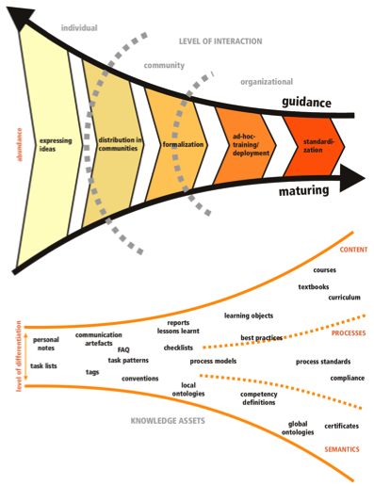

7. Implementation strategy for new studios and ateliers

Seminar contribution: Johannes Magenheim

Avoid the funding trap

Information literacy and lifelong learning are highly interrelated
They are both…..
- self directed and self-motivated and merged with processes of informal knowledge achievement which often takes place during working processes outside educational institutions. Nevertheless, they need advice and guidance.
- self-empowering in terms of general education and are aimed at all groups within a society disregarding gender race, social position etc..
- self-actuating which means that sustainable successful personal processes of acquiring Information Literacy and Life Long Learning Competencies are self accelerating and leads to a change of attitudes and habits of a person.
Source: Horton / UNESCO 2008

Key domain sectors
- Learning and Education
- Health and Human Services
- Business and Economic Development
- Empowering People to Vote and Participate in Governing

Studio implementation strategy
- Selecting a key sector domain where LLL and IL should be contextualized and where to gain local professionals and participants who are willing to co-operate (and already are running projects)
- Finding domain related ICT experts and connecting them to each other and the participants of the specific digital Studio. In order to establish international social networks.
- Organizing collaboration and co-operation through face to face meetings and via web- based technologies for computer supported collaborative working (CSCW) and Learning (CSCL). Besides conferences organize ‘twinning’ and ‘sistering’ arrangements or realize shepherding concepts

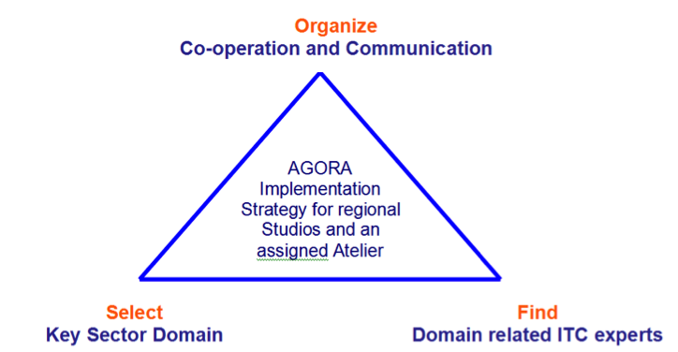
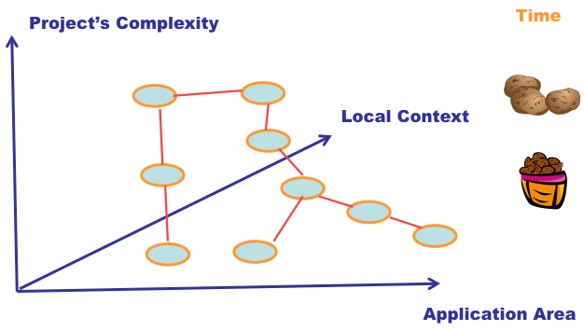
The concept of seeding and re-seeding

8. IFIP Agora Initiative on Lifelong Learning

8.1 Agora Initiative and Lifelong Learning in the World Conference Computers in Education 2009

Seminar contribution: Sindre Røsvik
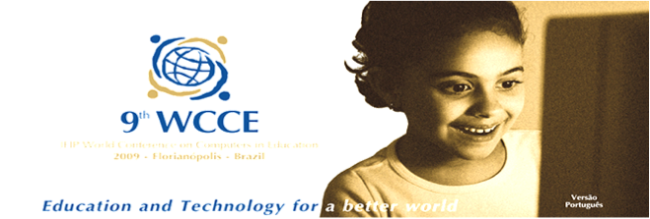
WCCE 2009 – Brazil Bento Goncalves 27.- 31.July - Education and Technology for a Better World
Some reflections on LLL
Individual perspective
–Lifelong learners from cradle to grave?
–Ability to learn/adopt to changes: “lasting change of attitude/behaviour”, to create :
• Professional, private: social, cultural, economic
• System, time, arena – do/learn, 2nd loop
• New information/experience = change of practice

Organisational perspective
– Organisations: structured or loosely coupled
– Learning organisations – communities of practice
•Not all organisations are learning organisations
•Schools are in general not learning organisations
•IFIP and TC3 are not learning organisations
•Ability to learn/change, find new ways of organising and working to meet challenges

Can IFIP/TC3 be a turned into learning organisation? Facilitate tradition or LLL?
From standalone events to continuity?
– WG
• Activities: Conferences, newsletters, book projects
• Membership with commitment to forming a learning community?
• Physical meeting/objects and digital/virtual arena
– AGORA
• Not a project but an approach
• Ongoing activities and set of initiatives, “real life/virtual community”

WCCE 2009 and AGORA
CONTRIBUTIONS – innovative
(A challenge for the AGORA initiative)
• Interactive collaborative sessions:
– Group signing on (2 or 3 presenters)/ Announce for partners on suggested theme
– Live blogs with contributions from audience
– Symposium: Set of three sessions aiming at producing a consensus document (i.e.: on free software, bridging the digital divide, policy declaration, Lifelong learning)
– TV-show style presentation: two-three short introductions organised by a programme leader with active involvement of the audience
– Or ???

8.2 Agora: An IFIP Initiative

Seminar contribution: Bernard Cornu

An IFIP initiative
• Focussed on Lifelong Learning…
…in a Knowledge Society
• Conceived in Paris (April 2006)
• Born in Poitiers, France (October 2006)
The AGORA Initiative takes into consideration the growing place of Lifelong Learning as a transversal theme in the information or knowledge society, and the growing need of networking and collaboration between partners and stakeholders.

Main Objectives
A. Dynamic and generic methodology for project initiation
How to initiate a network of cooperation projects,
with many different stakeholders?
B. Co-operation projects
Aimed at enhancing e-competence and knowledge
work competence of professionals and students
C. Methodical approach to knowledge sharing
Allowing contextual, local project efforts to be connected,
contributing in a synergetic manner to generic
knowledge about Lifelong Learning

Actions
A. Planning meetings (Poitiers, Paris, Seoul,…)
- Bringing together stakeholders and project initiators
- Knowledge sharing, networking and developing synergy
- Outlining of co-operation projects
- Defining work process for planning and co-operation
B. Seminars (Poitiers, Seoul, Addis Ababa, Krakow, Kuala Lumpur…)
- Sharing of local, contextual knowledge
- Interactive development of conceptual frameworks
C. Co-operation projects (4 in initiation phase)
- Developing e-competence and knowledge work competence of professionals and students
- Knowledge development and knowledge sharing

Results
A. Dynamic and generic methodology for project initiation
Studio – Atelier Methodology bringing together local initiatives
Agora Planning Meeting providing Atelier function
B. Co-operation projects
Managing Lifelong Learning Studio
Digital Divide Studio
Cyber-Teacher Studio
Croatian Studio
C. Methodical approach to knowledge sharing
Studio – Atelier Methodology bringing together local knowledge,
contributing to and partaking in generic knowledge
D. Conceptual frameworks
Seoul 2.0 Model & Addis Ababa 2.0 Model

Studio – Atelier Methodology
On the local context level Studios will be directed at real-world creation of practical instances of e-Education for Lifelong Learning in different areas of computer science education and educational use of ICT. Studios will provide contextual solutions, suitable for the cultural, social and economic context and for the special demands of the specific subject area of Lifelong Learning. On a generalizing and co-ordinating level AGORA introduces an Atelier which is mutually linked with the studios.
The ‘Atelier’-function:
- generate generic knowledge based on the experiences of the different studios.
- this knowledge can be applied in local ‘Studio’s’ where Lifelong Learning pilot implementations are realised.
- the generic educational Lifelong Learning model developed in the Atelier will be evaluated and improved in a process of critical review of the pilot implementations
- concurrently improve practice of Lifelong Learning in the local Studios.

Co-operation projects
“How to manage Lifelong Learning Studio”:
Impact of Lifelong Learning on the management of Education and Training; tools for managing Lifelong Learning

“Digital Divide Studio”
Lifelong Learning to reduce Digital Divide; Lifelong Learning for all to avoid a “Knowledge Divide”
“Cyber-Teacher Studio”
New competencies of Teachers and Trainers in the Lifelong Learning Society; how to build such competencies
“Croatian Studio”
Organising e-Learning for Croatian businesses and providing basic skills to managers

8.3 History of the IFIP AGORA Initiative

Seminar contribution: Raymond Morel

The AGORA Initiative on Lifelong Learning was launched by IFIP in Poitiers, France, last October. TC3 has played a major role in proposing and creating this project. The AGORA Initiative, an element of the process of revitalisation of the IFIP strategy, aims at implementing a dynamic methodology for initiating cooperation projects on Lifelong Learning with many different stakeholders. It is providing a methodical concept of action where contextual local efforts are connected to each other and contribute to generic common knowledge about Lifelong Learning in a synergetic manner.

Methodical concept of action: Local studios and generic Atelier
The methodical concept of “Atelier” was developed. The function of an “Atelier” is to generate generic knowledge based on the experience in different “studios”. This knowledge in its turn can be used to enhance the “studios” where Lifelong Learning pilot implementations are realised. In Seoul 4 international “studios” were created. Each “studio” will be directed at practical, real-world creation of practical instances of e-Education for Lifelong Learning. “Studios” will provide contextual solutions, suitable for the cultural, social and economic context.

In the Agora Initiative local LLL projects focus on specific objects and processes in specific contexts. The Initiative tries to study these projects as integral and meaningful phenomena allowing context-free generalizations. The projects provide contextual pilot implementations of LLL, called ‘Studios’. Context specific knowledge is developed in these Studios, but shared in an ‘Atelier’ linking the Studios. The ‘Atelier’-function generates generic knowledge based on the experiences in studios. This generic knowledge can then be applied in the local ‘Studio’s’ where Lifelong Learning pilot implementations are realised. Thus, the generic educational Lifelong Learning model developed in the Atelier will be evaluated and improved in a process of critical review of the pilot implementations and concurrently improve practice of Lifelong Learning in the local Studios. Methodological concept of action: Studios and Atelier

The 4 first AGORA studios were created during the Seoul seminar. These are:
- The “Cyber-Teacher Studio”, aiming at working on the new competences of Teachers and Trainers in the Lifelong Learning Society, and providing ideas, tools and resources for building such competences.
- The “Digital Divide Studio”, aiming at using Lifelong Learning as a mean to reduce the digital divide and aiming at making Lifelong Learning available for all, in order to avoid a “knowledge divide”.
- “How to manage and administrate Lifelong Learning”: The studio will work on the impact of Lifelong Learning on the management of Education and Training, and will provide tools for managing Lifelong Learning.
- The “Croatian Studio”, aiming at organising e-Learning for Croatian businesses and providing the basic skills to Managers.

Seoul 2.0 Model: How to become a learning organisation
The second AGORA event, a Seminar about Lifelong Learning, was held in Seoul, Korea, 3-4 June 2007. The result of this first “Atelier” on Lifelong Learning was created: “Seoul 2.0.”, a model helping IFIP to become a real “Learning Organisation” in the Lifelong Learning Society. The Seoul 2.0 Model for Learning Organisations is a practical analysis tool that helps managers and others to implement organisations that are sustainable in the knowledge society. The model is generic and applicable in different, specific contexts. The IFIP Agora Seoul seminar in 2007 (South-Korea) was used to test the effectiveness of the model for developed countries (http://www.ifip-tc3.net; choose: The IFIP Agora Initiative; choose: Agora in 2007). The model is based on earlier work in IFIP on ICT curricula and educational change (Anderson & van Weert, 2002) and on practical research conducted at SEM (Geneva, Switzerland), SATW, ICT Commission (Switzerland) and Hogeschool Utrecht, Chair ICT and higher Education (The Netherlands). Also use is made of the work of the European Foundation for Quality Management (EFQM)

Addis Ababa 2.0 Model: How to realise a lifelong learning environment
The Addis Ababa 2.0 Model for Learning Environments is a practical analysis tool for educational designers to build and implement a lifelong learning environment inside an existing organisation. The model helps to design the environment on four levels: personal, project, organisational and societal level. It takes account of the local organisational and societal context and results in an action plan suiting the particular situation. The Addis Abba 2.0 Model is integrated with the Seoul 2.0 Model. The IFIP Agora Addis Ababa seminar preceding WITFOR 2007 (Ethiopia) was used to test the effectiveness of the model for developing countries (http://www.ifip-tc3.net; choose: The IFIP Agora Initiative; choose: Agora in 2007).

AGORA Business Plan
In Seoul also the AGORA Business Plan was developed. AGORA will contribute in many future IFIP events. The next AGORA Conference will be held in Krakow, Poland, in 2008. All Technical Committees are welcome!

9. Krakow seminar organisation

9.1 List of participants

Ewa Bodzińska-Guzik
Bernard Cornu (Seminar Programme Chair)
Małgorzata Dudziak
Eduard Dundler
Barbara Kędzierska (Seminar Organiser)
Anna Kristjansdottir
Carolyn Medel- Anonuevo
Jerzy M. Mischke
Johannes Magenheim
Raymond Morel
Magdalena Przeszło
Danuta Rozpłoch-Nowakowska
Lampros Stergioulas
Maciej M. Sysło
Tom van Weert
Jan Wibe (IFIP Agora Chair)

9.2 Draft programme

Sunday, May 4 |  | Monday, May 5 |  | Tuesday, May 6
Time: |  | Time: |  | Time:
 |  | 09:00 – 09:30 | Introduction into the issues of the day : Spirit of the AGORA approach by Bernard Cornu and Raymond Morel | 09:00 – 09:30 | Johannes Magenheim :  Ateliers and Studios for the future
 |  | 09:30 – 10:15  10.15 – 11.00 | Carolyn Medel- Anonuevo  UNESCO institute for Life long learning (Hamburg)  Sindre Rosvik – AGORA and LLL in WCCE 2009  Barbara Kędzierska - Lifelong Learning in Higher Education, Polish Context | 09:30 – 10:00 | Bernard Cornu:  Continuation of AGORA and the Perspective of Further Plans  - When, where and what?  - WCC 2008 (September) in Milan, IFIP council March 2009 in New Delhi, WCCE 2009 (July) in Bento Goncalves Brazil, WITFOR 2009 (August) Hanoi
 |  | 11.00 – 11:15 | Coffee break | 10:00 – 11.45 | Proposals of events and proposals for designing and establishing ateliers and studios
 |  | 11:15 – 11:45 | Małgorzata Dudziak - Malopolskie Partnership for Lifelong Learning | 11.45 – 12:15 | Closing session :  Jan Wibe, Bernard Cornu and Barbara Kedzierska
 |  | 11:45 – 12:05 | Ewa Bodzińska-Guzik -  The Modern Forms of Professional Consultancy in the Realization of the Concept of Lifelong Learning in Malopolska
 |  | 12:05– 12:35 | Maciej Sysło - E-school – Regional Project in Educating Teachers
12:00 – 13:30 | Registration | 12:35 – 12:55 | Jerzy Mischke – E-learning in Lifelong Learning
13:30 – 14:15 | Opening session  Welcome and organising matters Barbara Kędzierska, presentation of participants and introduction by Raymond Morel on news from IFIP council | 12:55 – 13.10 | Danuta Rozpłoch – Nowakowska – E-learning at the University
14:15 – 15:00 | Tom van Weert.  The IFIP AGORA Progress in LLL | 13:10 – 14:00 | Lunch
15:00 – 15:50 | Lunch | 14:00 – 14:15 | Magdalena Przeszło - Citizen Education in Lifelong Learning – Polish context
15.50 – 16.30 | Lampros Stergioulas –  The EU project e-Start + outputs of ProLearn | 14:15 – 15:30 | Panel discussion – introduction and animation by Bernard Cornu  * The cyber teacher? | E-learning as a Tool of Cooperation in Europe in the Field of Lifelong Learning
 |  | 15:30 – 16:00 | Coffee break
18h30 | Social event at the Opera | 16:00 – 17:30 | Panel discussion –  - How to promote life long learning in existing educational system  Introduction and animation by Tom van Weert  - Using AGORA approach by IFIP for member societies –  Introduction and animation by Jan Wibe
 |  | 19.30 - | Official dinner

